

**Master of Technology in Intelligent Systems**

**ISY5001 Intelligent Reasoning Systems**

**Practice Module**

**Group Report**

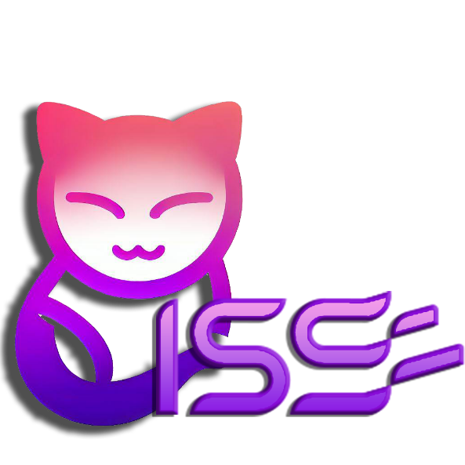

**ChattyISS - Improved NUS-ISS Chatbot**

**By Two.AI**

**Team Members**

Lee Kah Wai

Wee De Li, Darren

Seow Teck Han, Michael

Sankalp

1. Executive Summary 2

2. Introduction 3

2.1. Problem Statement 4

2.2. Proposed Solution 4

3. Github & Azure Location 5

4. Video Presentation 6

4.1. Business Presentation 6

4.2. Technical Presentation 6

5. System Design and Architecture 6

5.1. Concept 7

5.2. Architecture 7

5.2.1. Frontend 8

5.2.1.1 Cardinal requirements, Assumptions and Metrics 8

5.2.1.2 Possible solution(s) 9

5.2.1.3 Proposed solution and rationale 10

5.2.2. Backend Endpoint 10

5.2.2.1 Cardinal requirements, Assumptions and Metrics 10

5.2.2.2 Possible solution(s) 10

5.2.2.3 Proposed solution and rationale 11

5.2.3. Building our Knowledge base 11

5.2.3.1 Cardinal requirements, Assumptions and Metrics 11

5.2.3.2 Proposed solution and rationale 12

5.2.4. Chat Reasoning 17

5.2.4.1 Cardinal requirements, Assumptions and Metrics 18

5.2.4.2 Proposed solution and rationale 18

5.2.5. Optical Recognition for Text 23

5.2.5.1 Cardinal requirements, Assumptions and Metrics 23

5.2.5.2 Possible solution(s) 23

5.2.5.3 Proposed solution and rationale 24

5.2.6. Optical Recognition for Images 24

5.2.6.1 Cardinal requirements, Assumptions and Metrics 24

5.2.6.2 Possible solution(s) 25

5.2.6.3 Proposed solution and rationale 25

6. Technology Stack 25

7. System Implementation and Deployment 26

7.1. Server Installation and Setup 27

7.1.1 Installation setup 27

7.1.1.1 Backend Service 27

7.1.2 Frontend Service 28

7.1.2.1 Telegram Service 28

7.1.2.2 NUS-ISS Website 29

8. Testing and Test Results 29

8.1 Test Cases 30

9. Limitations and future enhancements 37

9.1 Limitations 38

9.2 Future Enhancements 38

10. Conclusion 38

11. Appendix 39

11.1. Appendix A1 – Project proposal 40

11.2. Appendix A2 – Mapped System Functionalities against knowledge, techniques and skills of modular courses: MR, RS, CGS 46

11.3. Appendix A3 – Installation and User Guide 46

11.3.1. Telegram application 46

11.3.2. ISS Website 47

11.4. Appendix A4 – Individual Project Report 48

11.5. Appendix B – Gartner Report 51

11.6. Appendix C – References 52

# Executive Summary

The project ChattyISS - Improved NUS-ISS Chatbot is a strategic initiative designed to address a gap in the current information delivery system of the NUS-ISS website. The website primarily caters to prospective students, with existing students facing challenges while seeking non-curriculum information or student guides. This difficulty, compounded by the limited capabilities of existing chatbots, hampers effective information search and discovery.

The current NUS-ISS chatbots struggle to deliver accurate and relevant responses, often limiting interactions to fixed responses and allowing scant room for follow-up queries. These systems also fail to offer an easy method for updates or extensions, making the maintenance of up-to-date information a significant challenge, particularly given frequent changes to the NUS-ISS curriculum.

The ChattyISS project aims to improve these existing chatbots, thereby providing an enriched and more interactive experience for users. This project envisions creating a sophisticated AI-driven chatbot, designed to handle a wider variety of queries, engage in more extended and dynamic interactions, and ensure the easy and swift update of information.

The introduction of the improved NUS-ISS chatbot is expected to streamline information accessibility for both prospective and current students, delivering accurate and pertinent information in real-time. By doing so, we aim to enhance user engagement, reduce the time spent on information search, and increase overall user satisfaction with the NUS-ISS digital interface.

# Introduction

## Problem Statement

The current NUS-ISS website is targeted at prospective students rather than existing students. It is difficult to search for related information and data pertaining to non-curriculum (such as nearest canteen, nearest facilities) or student guides (student handbooks).

 It has been identified that there are already existing NUS-ISS chatbots developed. These NUS-ISS chatbots cannot provide accurate responses to queries and are confined to fixed responses. They only accept limited follow-up questions. These chatbots are also outdated and do not provide easy means for extension. Frequent changes to the NUS-ISS curriculum or information could not be easily updated into the chat system.

In summary, the problems of existing solutions can be summarised in the following points

* Relevancy of information
* Difficulty of updating information

## Proposed Solution

The proposed intelligent chatbot is going to address these gaps of the current NUS-ISS chatbots. The delivery of the MVP (Minimum Viable Prototype) is going to demonstrate the chatbot’s capability of delivering accurate and up-to-date information.

 The following diagram illustrates the business flow for the proposed solution.

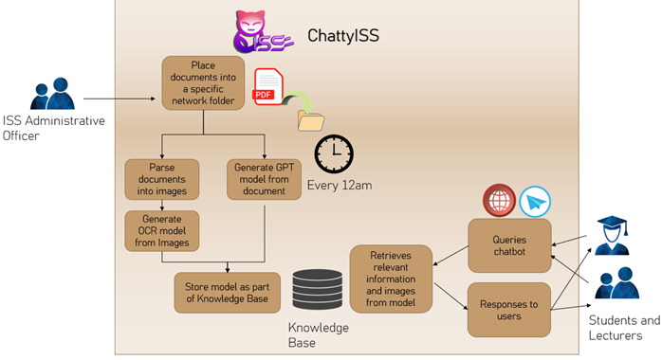

Figure 1: Overall Proposed Solution

The business flow can be summarized in the table below:

|  |  |
| --- | --- |
| Updating knowledge base | |
| Administrative Officer | * Insert documents in the folder |
| ChattyISS | * At 12am sharp, the documents are being parsed separately by 2 sub-systems. * Image Understanding * The documents are broken into different images, each page representing a jpg file. * Different OCR models are used to understand these images and the information of each image is captured into different json files. * Document Understanding * The documents are first converted into text and trained using Generative Pretrained Models. |
| Queries using Telegram Chatbot or ISS website | |
| Lecturers / Students | * Key in query to via Telegram bot application or ISS website |
| ChattyISS | * ChattyISS queries the knowledge base for relevant responses and images for each query and response back to the front-end the user used. |

There is no requirement to standardize the different documents into certain formats. The administrative officers can take whatever PDF documents the lecturers/school have prepared and insert them into the network folder directly. ChattyISS shall be able to parse these documents using the Generative Pretrained Models without fail. This enables a quick and easy method to update the existing knowledge with up-to-date information.

Note that for this current iteration of minimum viable product, only PDF files will be used.

# Github & Azure Location

The Github repository for Chatty ISS could be found in the following URL:

[sink257/IRS-PM-2023-03-06-ISY5001-GRP-Two.AI-ChattyISS (github.com)](https://github.com/sink257/IRS-PM-2023-03-06-ISY5001-GRP-Two.AI-ChattyISS)

The Azure NUS-ISS website can be found in the following URL:

<http://20.163.11.67:8000>

# Video Presentation

## Business Presentation

The business presentation is stored in the following location:

<https://github.com/sink257/IRS-PM-2023-03-06-ISY5001-GRP-Two.AI-ChattyISS/blob/79425209a9f4e09760a2bd16edba03e5bc36c583/Video/ChattyISS%20Business%20Video%20Presentation.mp4>

## Technical Presentation

<https://github.com/sink257/IRS-PM-2023-03-06-ISY5001-GRP-Two.AI-ChattyISS/blob/main/Video/ChattyISS%20Technical%20Video%20Presentation.mp4>

# System Design and Architecture

## Concept

The concept for our approach to system design can be captured in the following flowchart:

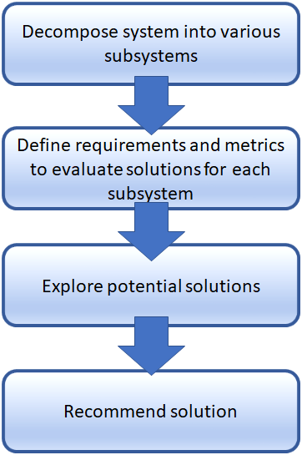

Figure 2: Design Approach

* Decompose the overall solution into its constituent subsystems.
* Determine the primary requirements, assumptions, and metrics for each subsystem.
* Explore potential solution(s) for each subsystem.
* Recommend a specific solution for each subsystem and explain the reasoning behind it.

## Architecture

The general architecture of the chat system is illustrated in the diagram below.

As mentioned above, each of the sub system is discussed in depth in the following subsections.

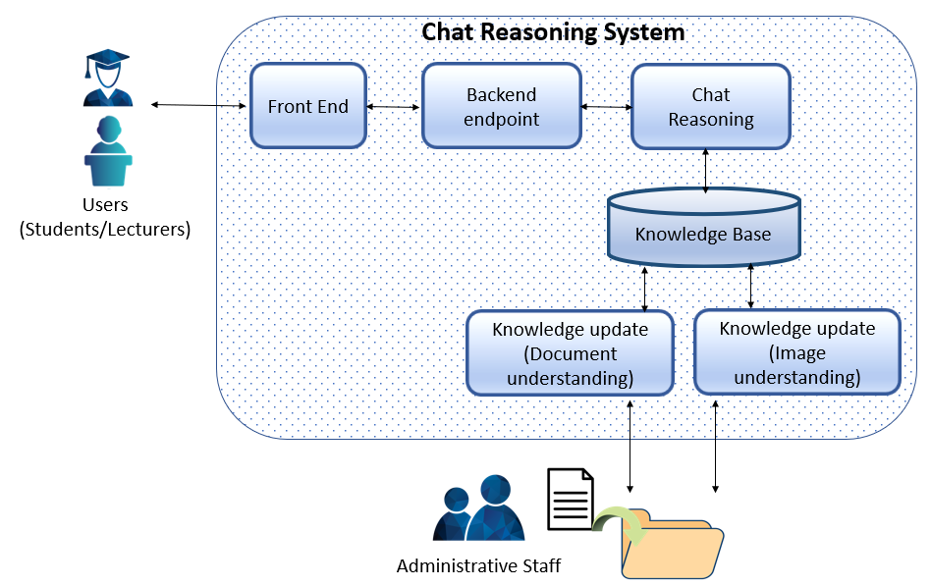

Figure 3: Architecture for Chatbot System

The system could be broken down into 6 main components.

* The front end represents the Human machine interface used by potential users of the systems (Students/Lecturers).
* The backend endpoint represents the endpoint technology to receive and respond to queries from the front end.
* The chat reasoning and knowledge base represents the core reasoning system for our chatbot system.
* The knowledge base stores the knowledge for the reasoning system.
* The knowledge update module (Document understanding) parses the document into chunks of knowledge into the knowledge base.
* The knowledge update module (Image understanding) parses the document into several images and each image represented with words related to it.

## Frontend

### 5.2.1.1 Cardinal requirements, Assumptions and Metrics

**Cardinal Requirements:**

The solution should provide an easy-to-use front end to facilitate various users (Students, Lecturers, Administration officers) of the system.

**Assumptions made:**

System has access to the NUS-ISS web page.

**Metrics:**  
The following [metrics](https://www.testingtime.com/en/blog/important-ux-kpis/) are commonly used for UX design

#### Time-on-task

#### This KPI describes the time (in minutes and seconds) that a user needs to complete a task successfully. Time on Task = Time taken to install the bot (Client) + Time taken to key in a query

#### User Error Rate

#### This refers to the possible error rate for (Not applicable as error rate will be same for similar technologies)

#### We will only use the time-on-task as a metric to decide the front end to be used. Apart from quantifying metrics solely on the solution, we should also consider metrics of the platform used.

#### Commonly used platforms

This is an important factor because human machine interface has strong reliance on the platform they used. For example, a teenager would typically use mobile phone more than an adult. Our system does not need to cater for a variety of users. Our main users are NUS-ISS students, lecturers and the administrative officers of NUS-ISS.

### 5.2.1.2 Possible solution(s)

**Solution 1: A bot hosted in Telegram Application**

To create a bot written in python on a machine using the Telebot API.

Time on Task (in seconds) = Time taken to install the bot (Client)+ Time taken to key in a query

= 5 + 1 = 6s

**Solution 2: A chat embedded into NUS-ISS website**

To create an iframe popup using HTML/Javascript/CSS to create a chat dialog within the ISS website.

Time on Task (in seconds) = Time taken to install the bot + Time taken to key in a query

= 0 + 1 = 1s

Just using quantification metrics alone, embedding the chat onto the webpage will be the most viable solution. However, we do need to consider the platform used.

|  |  |
| --- | --- |
| Users | % Reliance on smart phones |
| Students | 28% |
| Staff (Lecturers/Administrative officers) | 11% |

### 5.2.1.3 Proposed solution and rationale

Based on the metrics, the better approach would be to create both front ends to target both students and staff.

In addition, we should not restrict our users on the types of front end for our clients. Our clients may have their own preferred front ends to their users. Therefore, the proposed front end should be a **pluggable front-end solution** to retrieve questions and answers from the backend endpoint using a pre-defined defined RESTFUL API.

## Backend Endpoint

### 5.2.2.1 Cardinal requirements, Assumptions and Metrics

**Cardinal Requirements:**

The solution should provide a simple query API to

* Listen for incoming queries from users.
* Retrieves responses from Chat Reasoning System.
* Provide a response to front-end.

**Assumptions:**

This is a NUS-ISS chatbot, we assume that there will not be hundreds or thousands of requests per seconds. The metric used should just be a simple latency

**Metrics:**

The following metrics3 are commonly used for accessing web endpoints

#### Average and Max Latency

#### Round trip time from accessing a web query to a web response.

Apart from latency, there are some other qualifying conditions to access the use of the endpoint.

#### Ease of maintenance. (Compatibility with chat reasoning system)

How easy is it to maintain the Chat Reasoning System.

### 5.2.2.2 Possible solution(s)

**Solution 1: Web endpoint using Java Spring Framework**

A web endpoint written in Java that provides highly customizable solution for Enterprise.

Latency: negligible (The query speed is dependent on Chat reasoning rather than endpoint)

**Solution 2: Flask server using Python**

A lightweight web endpoint in python.

Latency: negligible (The query speed is dependent on Chat reasoning rather than endpoint)

**Solution 3: Http Server written in low level languages (C++/Rust)**

A http server written with high performance programming language aimed to achieve low latency.

Latency: negligible (The query speed is dependent on Chat reasoning rather than endpoint)

### 5.2.2.3 Proposed solution and rationale

Since there’s no significant improvements (in terms of latency) when compared against the different technologies, Solution 3 which targets high performance is not really a necessary option. For the backend, with existing integration to Python libraries, the most logical approach is to adopt Flask server which is implemented in Python.

## Building our Knowledge base

### 5.2.3.1 Cardinal requirements, Assumptions and Metrics

**Cardinal Requirements:**

The solution should seek to have the following processes:

1. Document Preprocessing: The documents need to be preprocessed to remove irrelevant information, such as punctuation, stopwords, and special characters. This step helps clean the text and improve the quality of word embeddings.
   1. Script should also process different extensions of documents (pdf, txt, docx, csv)
2. Tokenization: The text in the documents should be tokenized, breaking it down into individual words or phrases. Tokenization enables the creation of word embeddings at a granular level.
3. Word Embedding Generation: Each word or phrase needs to be converted into a word embedding, which represents its meaning or context. The word embedding generation process should capture semantic relationships between words accurately.
4. Vector Store: A vector store or index structure should be established to efficiently store the generated word embeddings. The vector store should be capable of handling high-dimensional vectors and provide fast storage and retrieval operations.
5. Accuracy: The word embeddings should accurately capture the semantic relationships between words and documents. The similarity measurements should provide reliable results, enabling the retrieval of relevant and similar documents.

By addressing these cardinal requirements, the system can effectively process and store documents as word embeddings in a vector store, facilitating efficient querying and retrieval of similar documents based on user queries.

### 5.2.3.2 Proposed solution and rationale

Package used: LangChain – a framework built around Large Language Models, which allows users to chain different components like prompt templates to form advanced use cases like generative question answering.

LangChain provides a simple framework with functionality to do document processing with access to different embedding models like OpenAI and huggingmodel models like BLOOM. After processing, we are able to store our embeddings into a vector store of our choice.

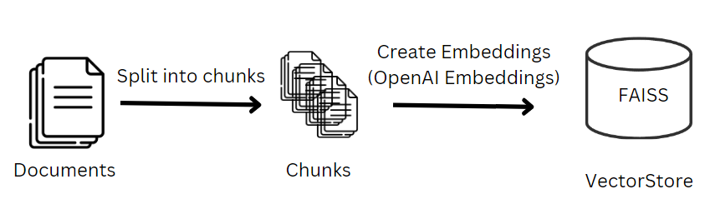

Figure 4 Document Preprocessing into Vector Store

We load the relevant documents, pre-processing them and splitting them into chunks. These chunks are then passed into our word embedding model, creating embeddings, which we will store into a Vector Store.

Below is the breakdown of creating our Knowledge base, which we will use for our question answering bot in the below sections:

**Importing necessary libraries**

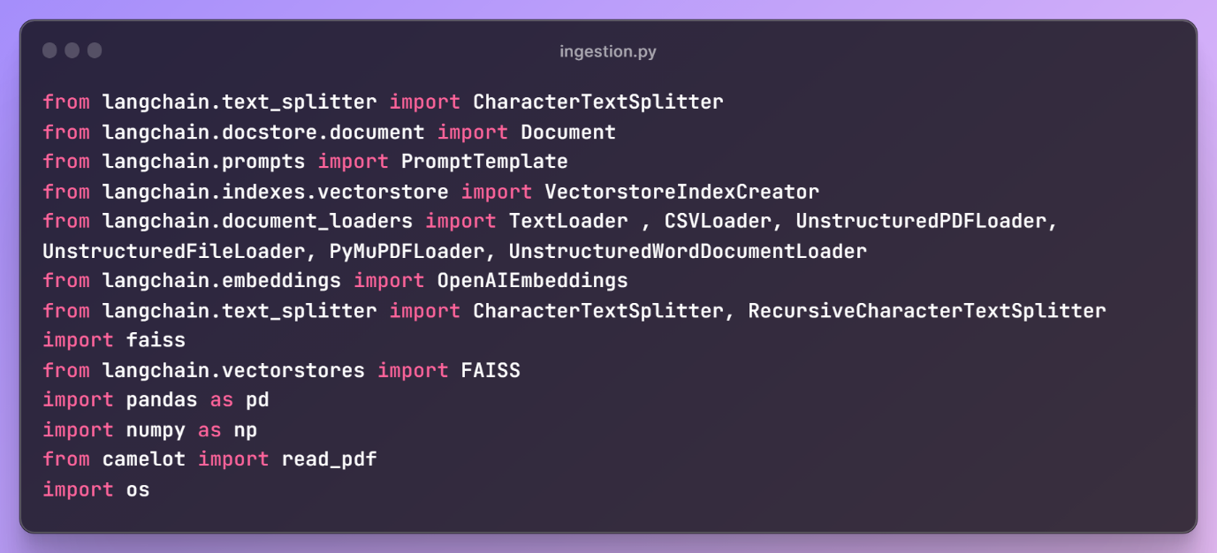

We start off first by importing all necessary libraries, which will be required in our script ingestion.

**Declaring OpenAI key**

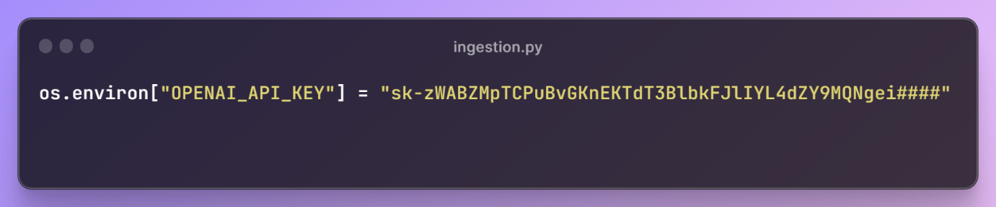

Declaring our OpenAI key as we will be using its embedding models and gpt-service for the question answering bot. Note: we have censored the key here for privacy purposes.

**Listing our directory and getting paths of all files**

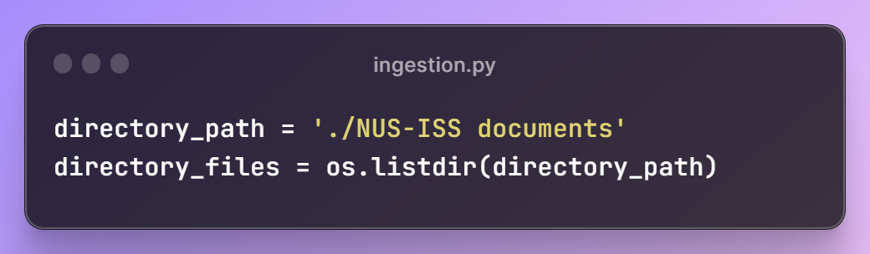

**Declaring the pre-processing text splitter and embedding model**

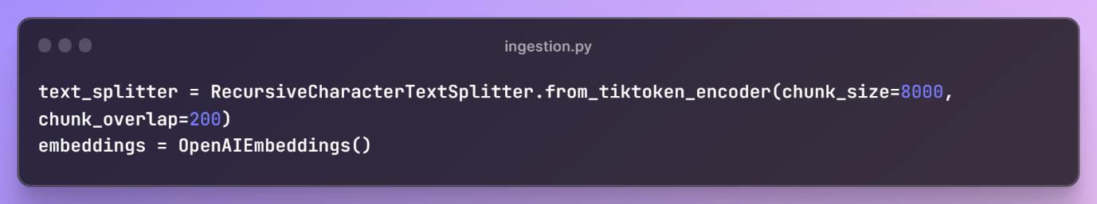

We set our embedding model here to OpenAIEmbeddings, which will help us to convert the chunks into word embeddings based on the OpenAI model in our pre-processing step.

The RecursiveCharacterTextSplitter is a text splitter parametized by a list of characters, such as ["\n\n", "\n", " ", ""]. The splitter will split the document and its content in order until the chunks are small enough. This has the effect of trying to keep all paragraphs (and then sentences, and then words) together as long as possible, as those would generically seem to be the strongest semantically related pieces of text.

Over here, we have set the chunk_size to 8000 and the overlap to be 200. This means that each chunk will contain 8000 characters, with 200 characters overlapping between each chunk to maintain some continuity.   
  
One important point here to note that when we are querying from the vector store when receiving a query, we will take the top K important chunks as context to feed into the Large Language Model. The chunk size is important over here as Large Language Model (OpenAI) have a token limit to the information that we can send through its api.

Therefore, we have different chunk sizes for different gpt-models based on their limitations:  
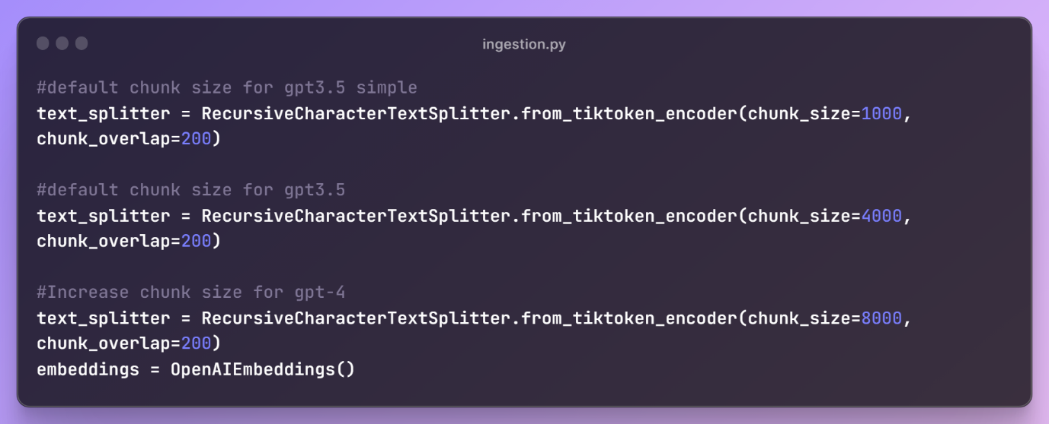

**Processing all documents and feeding into the Vector Store**

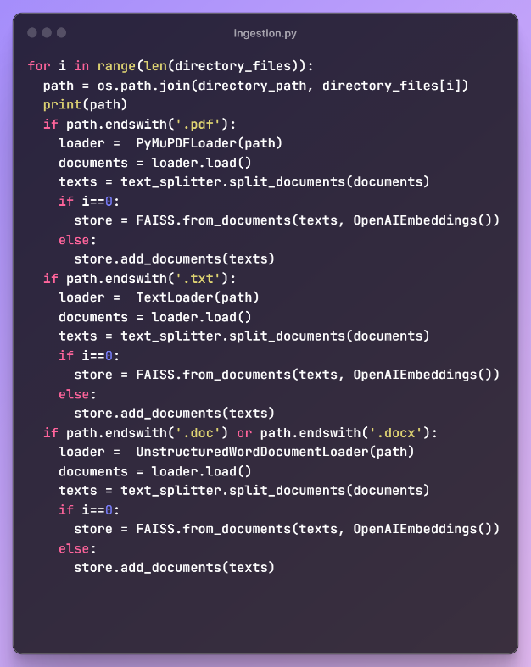

Now that we have declare our text splitter and embedding model, we can start to read in all the files in our directory path while have all the NUS-ISS documents related to Frequently Asked Questions, Professors, and school information.

The ingestion script is split into different if statements, since we foresee that documents would have different extension types, from pdf to word documents, and each would require their own document loader as seen above.

Once the document is loaded, the text splitter will split the documents into multiple chunks, as seen from the code below:

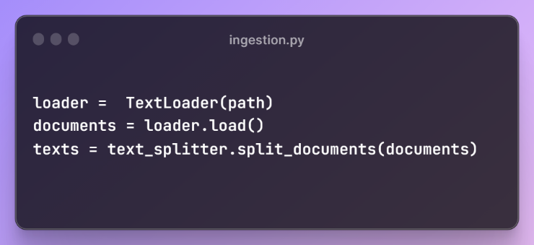

We then add the chunks into our vector store, which would store all of our document embeddings. Note that we are using FAISS as our choice of vector store, but there are other choices like Chroma or Weviate. We chose FAISS as it is able to allow the storage of the vector store in our local machine, giving us an ease of convenience:

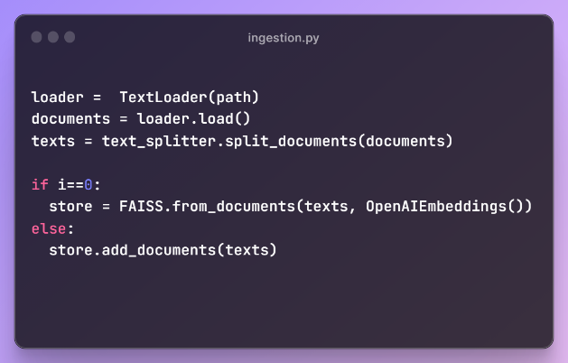

**Separate Processing for Timetables with tables**

As timetables need to be processed differently, compared to the other documents with just texts, we provided a separate script to process these files in a subfolder:

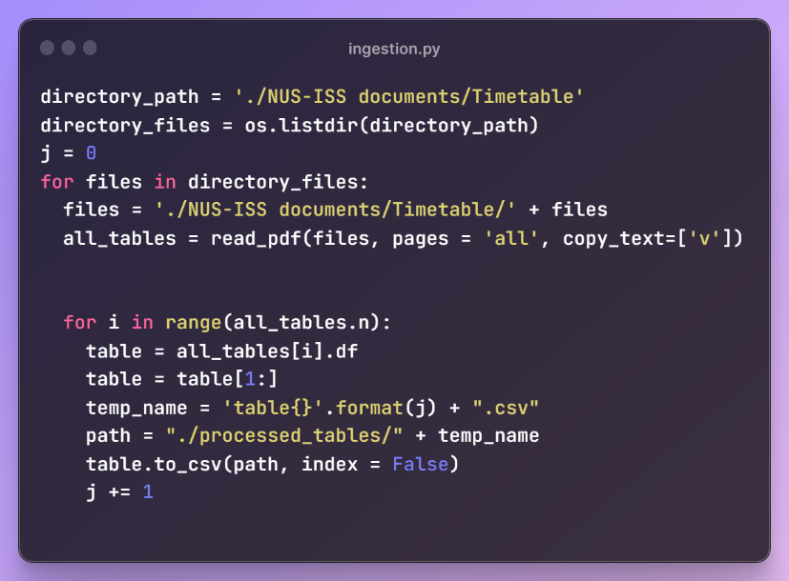

**Note: In order for the pdf reader to work, user would need to have Ghost Script installed on their OS - https://ghostscript.com/docs/9.54.0/Install.htm**

The above script will read individual pdfs using Optical Character Recognition which have the timetable information provided by the school and output them in a table form. We then output this table into a csv and process it into our Vector Store:

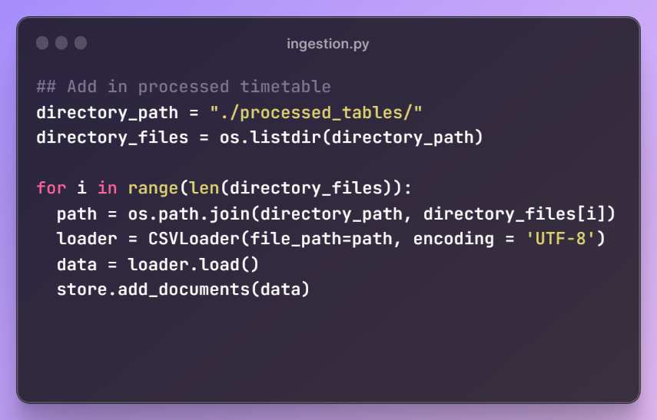

The CSVLoader here helps to load each row as a record into our Vector Store, along with its headers as keys to provide context. For example, the processed csv below:

   
will be loaded into our Vector Store as

Document(page_content='Course\xa0Code: SFBS‐NF\nCourse\xa0Name: Statistics\xa0for\xa0Business\xa0II\nLecturer(s): Charles\xa0(Course\xa0Mgr)\nChristine\nLim\xa0Suang\nDay: Saturday\nTime: 9am\xa0‐\xa05pm\n ……….

By doing so, this helps to give context when passing into the Vector Store, which will help us gather accurate information like Beacon referring to a classroom.

**Storing our Vector Store into local machine**

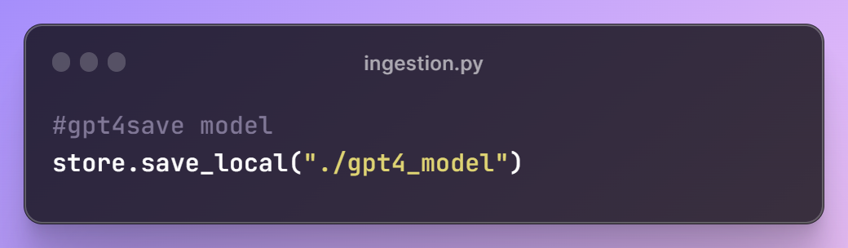

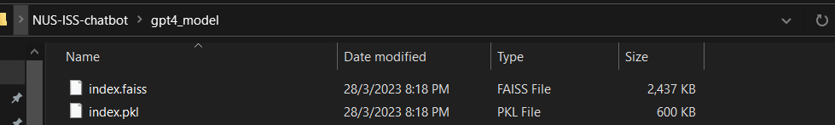

Once we have load and transform all our documents into word embeddings and store them in our Vector Store, we are able to save it into our local machine. This will enable us to have the vector store offline and does not require us to do processing every time we run our chat bot. And we are done, we have our Vector Store ready to go!

## Chat Reasoning

### 5.2.4.1 Cardinal requirements, Assumptions and Metrics

**Cardinal Requirements:**

The solution should seek to have the following processes:

1. Querying the Vector Store: The framework needs to query the vector store using the user's question. The vector store should efficiently retrieve the top k most similar documents based on the similarity of their word embeddings to the query embeddings.
2. Document Retrieval: The chatbot should retrieve the relevant documents from the vector store, using similarity against the query vector. These documents will serve as additional content to enhance the context and knowledge available to the large language model to answer our query.
3. Answer Generation: The chatbot should utilize the integrated knowledge from the similar documents and its language model to generate an appropriate answer to the user's question. It should consider the context, relevant facts, and the intent behind the question to produce a meaningful and accurate response.

### 5.2.4.2 Proposed solution and rationale

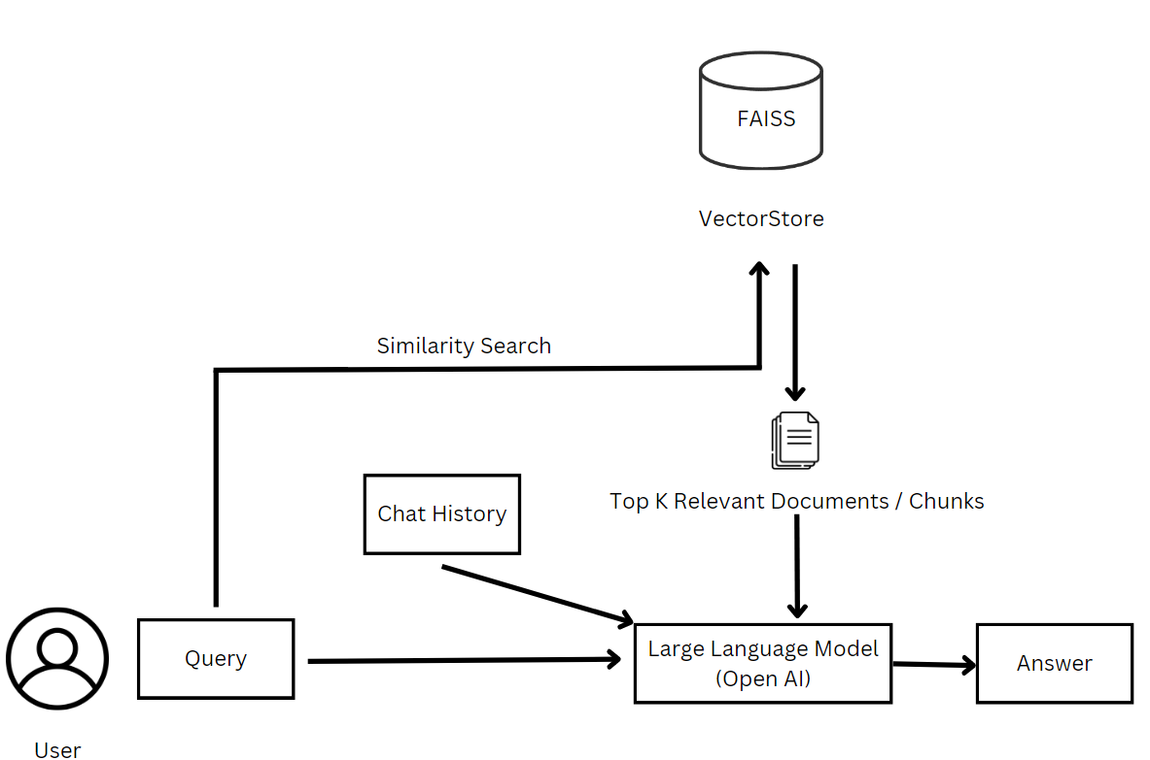

This is the final framework for our chatbot. The user will first ask a question, posed as query. This query will go through the same pre-processing as above and transformed into a word embedding. We then query our Vector Store that we have created, finding the top K relevant chunks based on their embeddings that are the most similar to the query embeddings. After retrieving the chunks, we feed both the query and the similar documents into the large language model, in our case, OpenAI’s chat-gpt. This information will be included in a custom prompt template, where we will get chat-gpt to generate our answer based on the query and the information given.

Below is the breakdown of our framework:

**Importing necessary libraries**

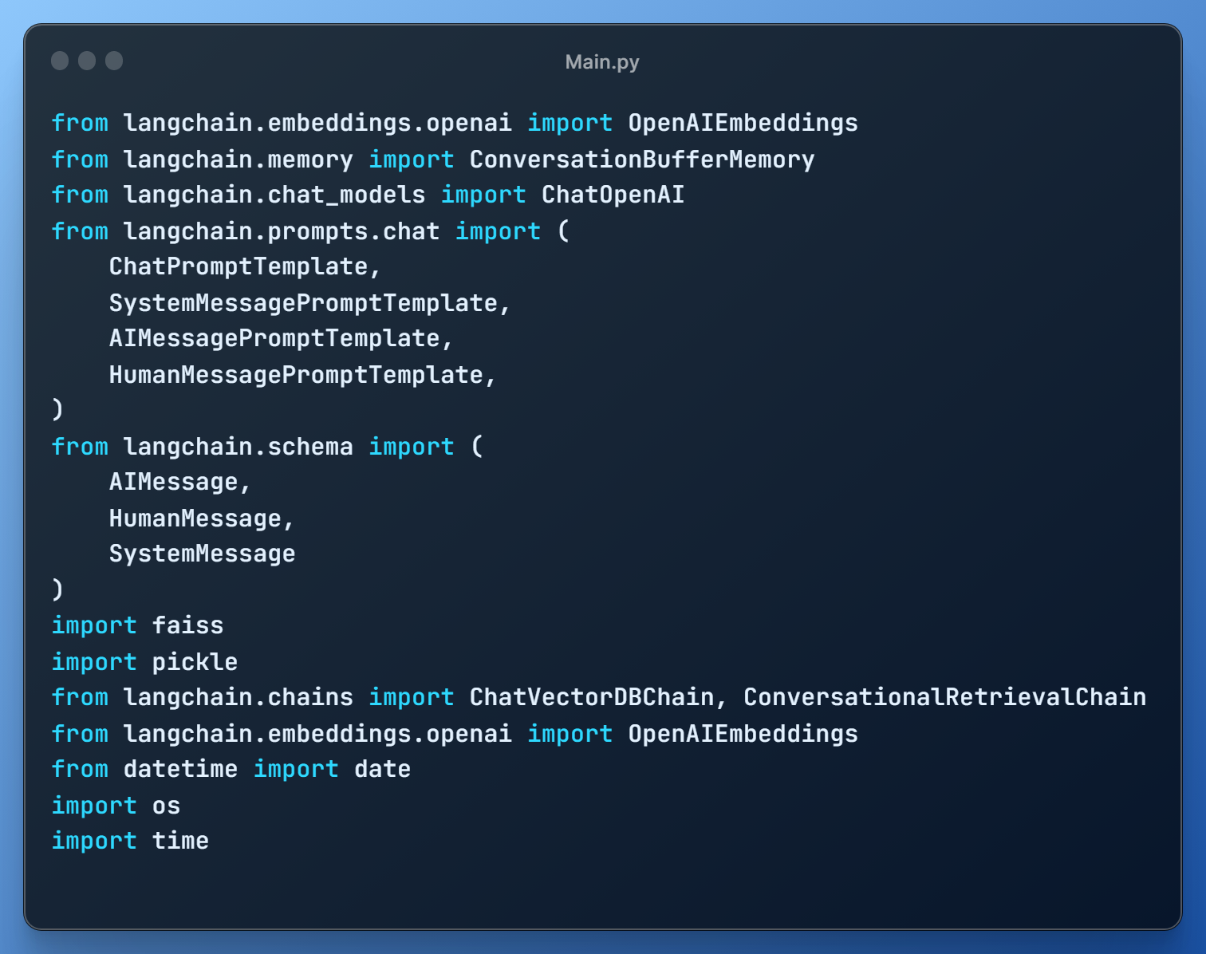

**Declaring our prompt template for chat-gpt**

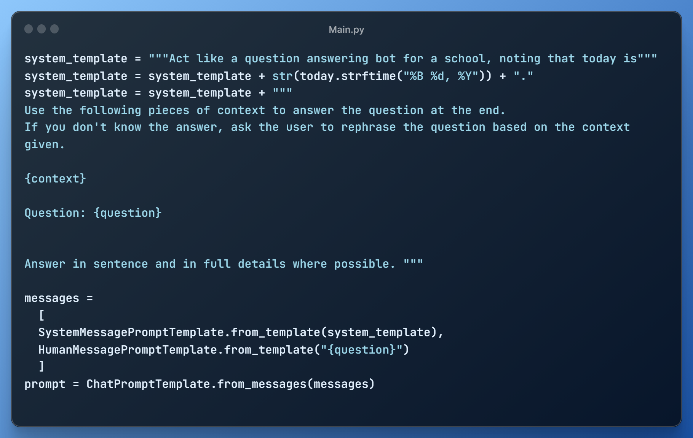

We declare our prompt template, which is the most crucial part of the framework, as we will task chat-gpt its role as a question answering bot, asking it to generate an answer using following pieces of context.

Note that we have added additional context here:

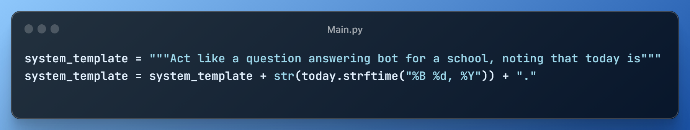

As chat-gpt does not have context of today’s date, questions such as “Where is the classroom for reasoning systems today ?” or “what time is the class for cognitive systems next week?” will not return an answer. As such, we manually input today’s date into the prompt template, letting chat-gpt know, which will help to answer the above queries successfully based on the timetable context.

**Retrieving our Vector Store**

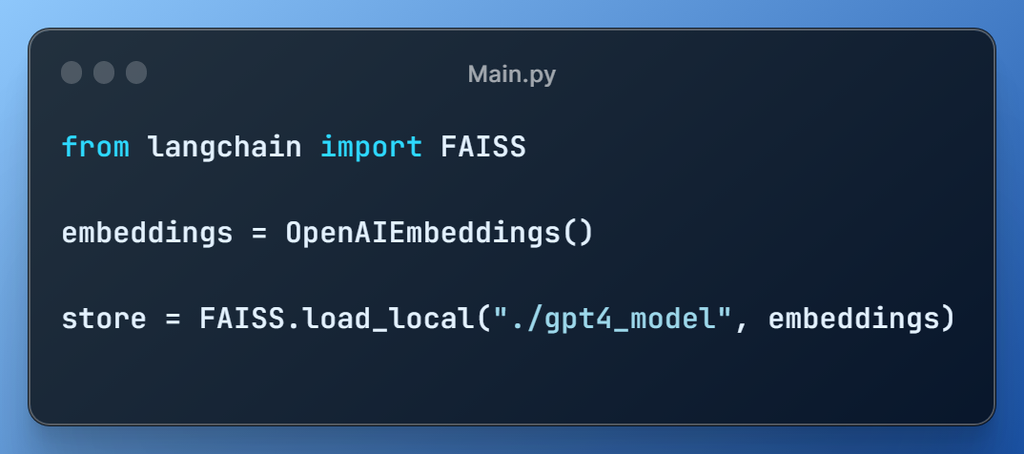

Similar to our section on ingestion, we declare our embedding model as OpenAI embeddings and we load our Vector Store which we have saved into our local system.

**Setting up our ‘Chain’**

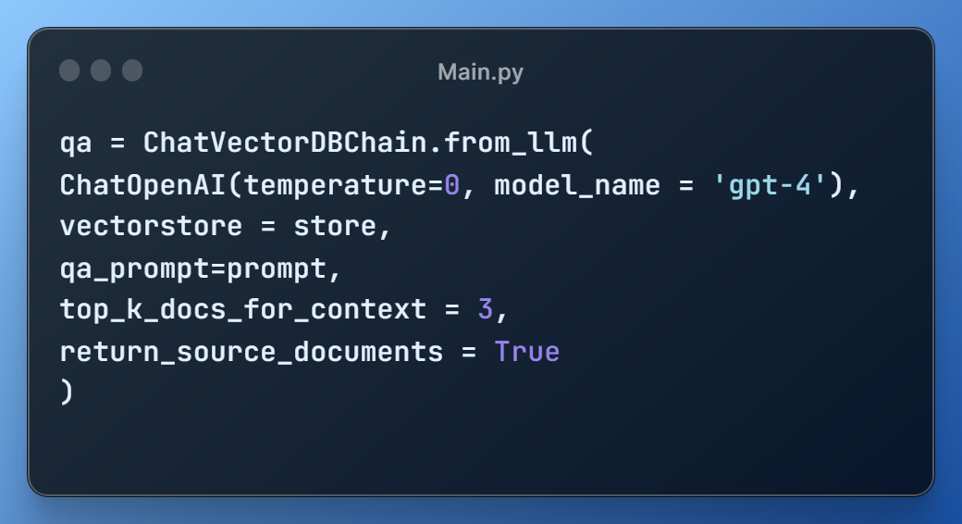

We use the ChatVectorDBChain, one of the preconfigured chain provided by LangChain package, which lets us connect to a OpenAI Large Language Model that stores chat history and retrieves context from our FAISS Vector Store. The qa function will then generate a result answer to the provided query.

We package all of the above into one function, which we can use to call later:  
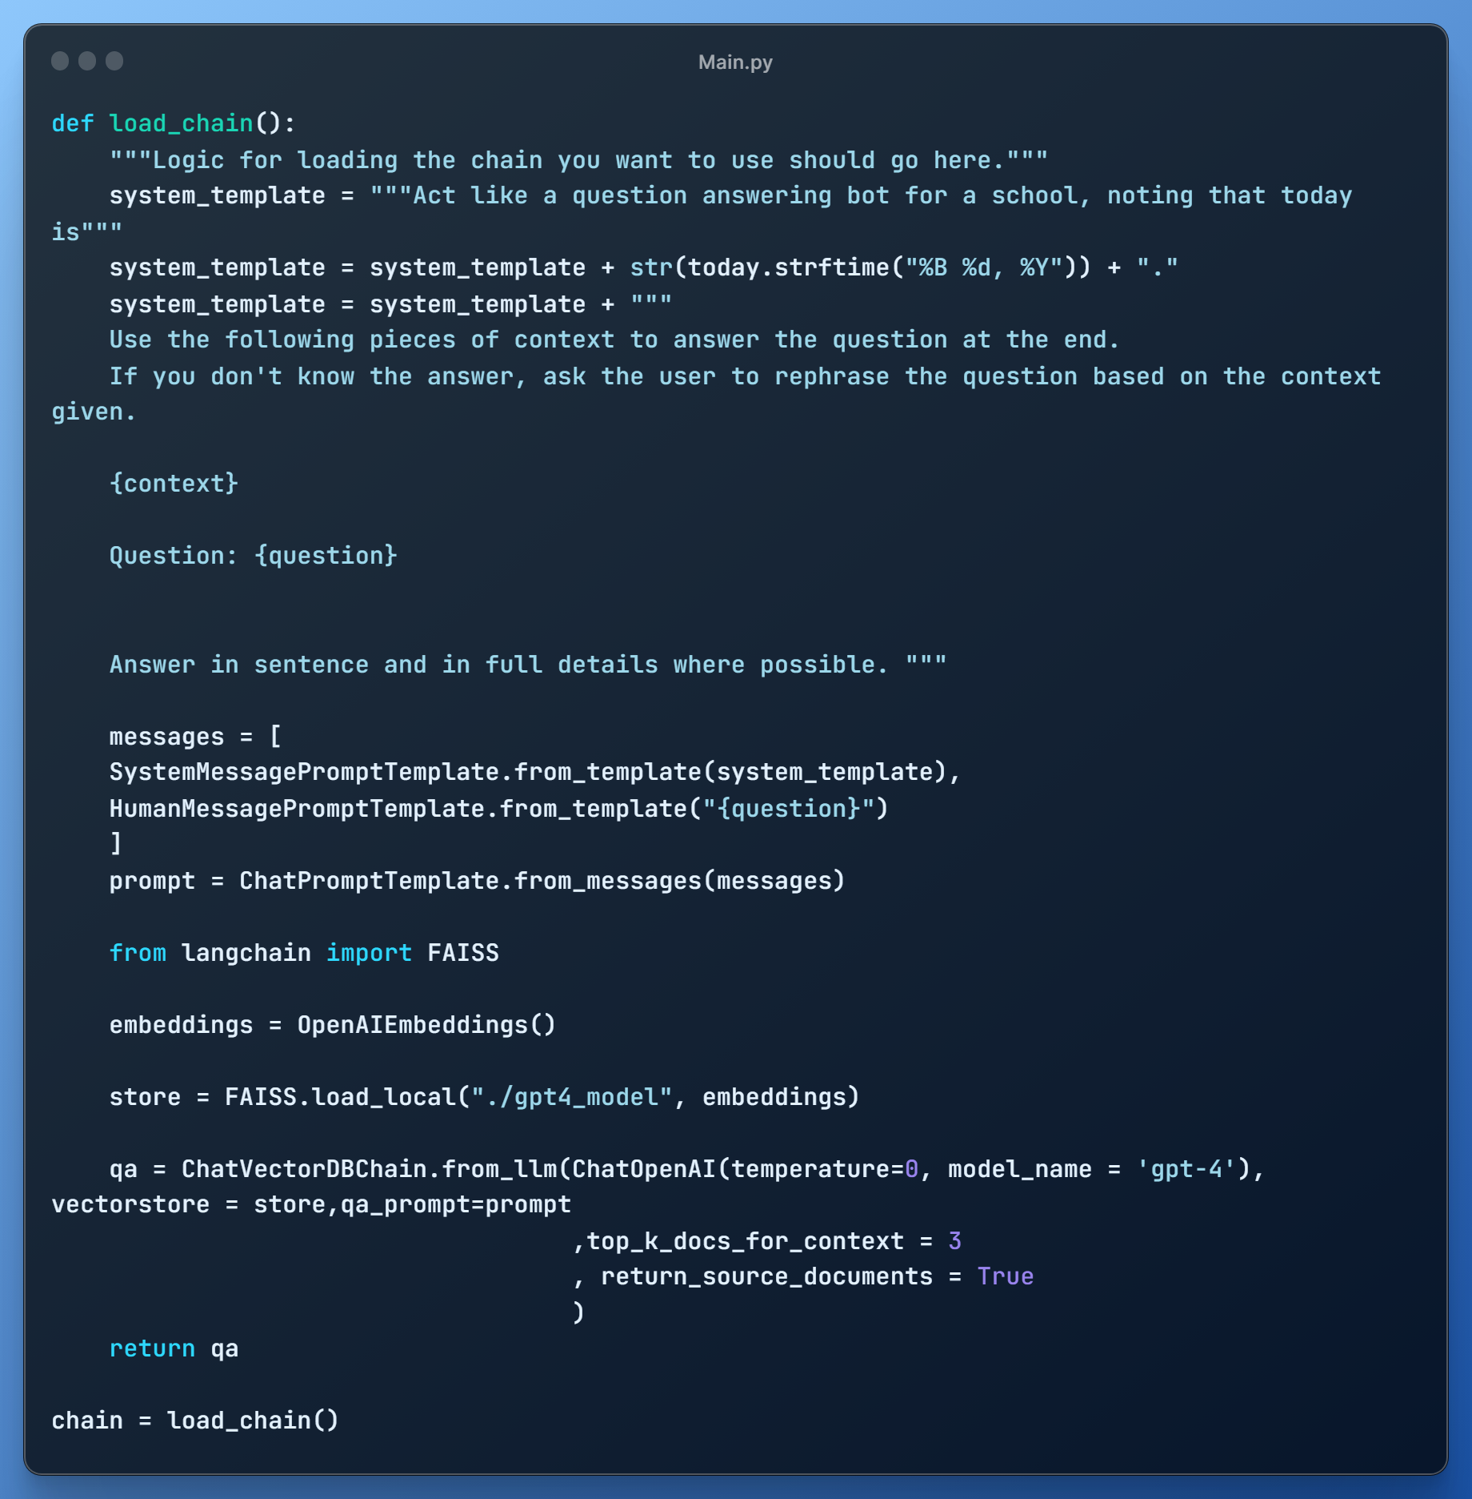

**Calling our chain as chatbot**

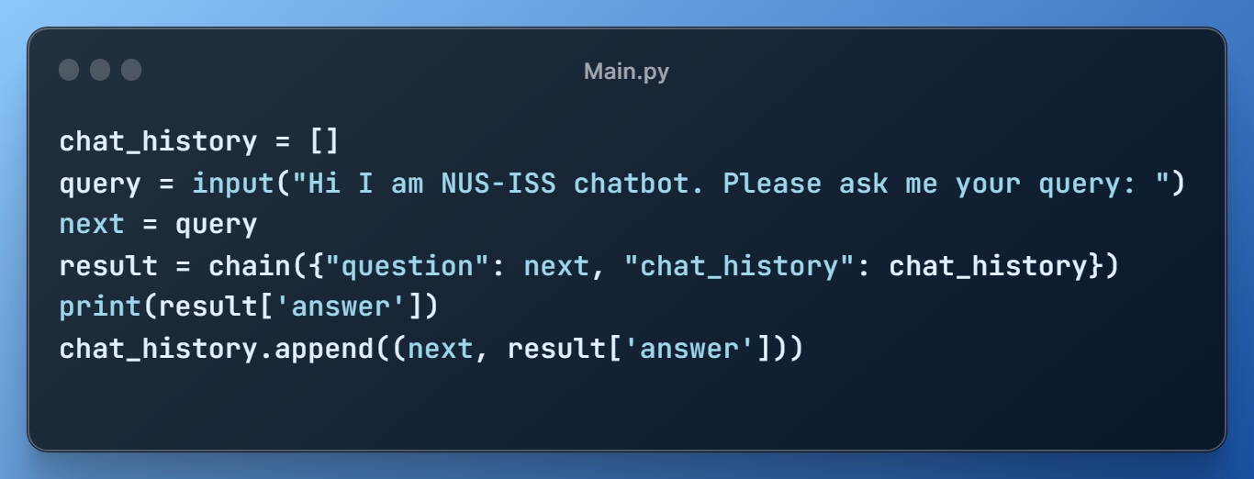

The user is given the ability to input their query, which is then passed through our established chain function. Furthermore, we maintain a list called chat_history, which contains the past queries in the conversation. This enables the chatbot to maintain continuity and context. For instance, when answering a question like "Where did he previously work?" following the query "Who is Sam Gu Zhan?", the chatbot can establish a connection between the pronoun 'he' and Sam by referring to the chat history.

Note: as multiple queries and results added to the list of chat history will result in a limit exceeded when passing to the api service, we have introduced a frontend process, where the chat history will be refreshed 5 mins after once there is no query.

And we have our chatbot model ready to go, which we will link to our frontend.

## Optical Recognition for Text

### 5.2.5.1 Cardinal requirements, Assumptions and Metrics

**Cardinal Requirements:**

The solution should provide simple query API to

* Listen for incoming queries from users
* Retrieve responses from the optical text recognition system
* Pass the data to the embedding for further processing

**Assumptions made:**

System database has document files with text inside. The quality of the document is of a high resolution and good quality. The document should also be in English.

**Metrics:**

For metrics, we can use accuracy, precision and recall to measure the simple effectiveness of the optical text recognition system. Additionally, metrics such as Character Error Rate and Word Error Rate can be used to check the character and world level errors respectively. This is slightly more useful as it takes into account the number and type of errors, and not simply checking if there was an error made.

### 5.2.5.2 Possible solution(s)

**Solution 1: Return text based on uploaded documents**

This solution is fairly straightforward to implement but the documents must be thoroughly checked to ensure that they are displaying text correctly and there are no formatting errors.

**Solution 2: Make a document scanning application for mobile**

This solution is harder to implement as it requires domain knowledge of mobile applications. However, this solution lets us quickly scan in items that are printed such as handwritten documents and receipts.

### 5.2.5.3 Proposed solution and rationale

For our proposed solution, we are selecting Solution 1 above, as it provides the best mix between precision and recall. The following diagram shows the main design of the image recognition and processing subsystem.



## Optical Recognition for Images

### 5.2.6.1 Cardinal requirements, Assumptions and Metrics

**Cardinal Requirements:**

The solution should provide a simple query API to

* Listen for incoming queries from users
* Retrieve responses from Image Reasoning System
* Return an image to front-end

**Assumptions:**

The images used in the system contains useful text information that can be matched to the user’s requests.

**Metrics:**

For metrics we can use accuracy, precision and recall to measure the effectiveness of the Image Processing subsystem, or how often the image returned is relevant to the user query.

### 5.2.6.2 Possible solution(s)

**Solution 1: Return an image based on filename and/or descriptive metadata**

Simple solution to implement, however, manual work must be done to give the images properly relevant file names and metadata. Accuracy is high for this solution, but recall is low.

**Solution 2: Use OCR to process the text data from the image**

Good solution for text-heavy images. After the text is extracted, it can be converted into a vector-based word embedding form to be used together with the main chat reasoning system.

**Solution 3: Train an Image Recognition model to recognise the image**

Unlikely to perform well, as most of the images used are based on word documents and therefore look very similar to each other.

### 5.2.6.3 Proposed solution and rationale

For our proposed solution, we are selecting Solution 2 above, as it provides the best mix between precision and recall. The following diagram shows the main design of the image recognition and processing subsystem.

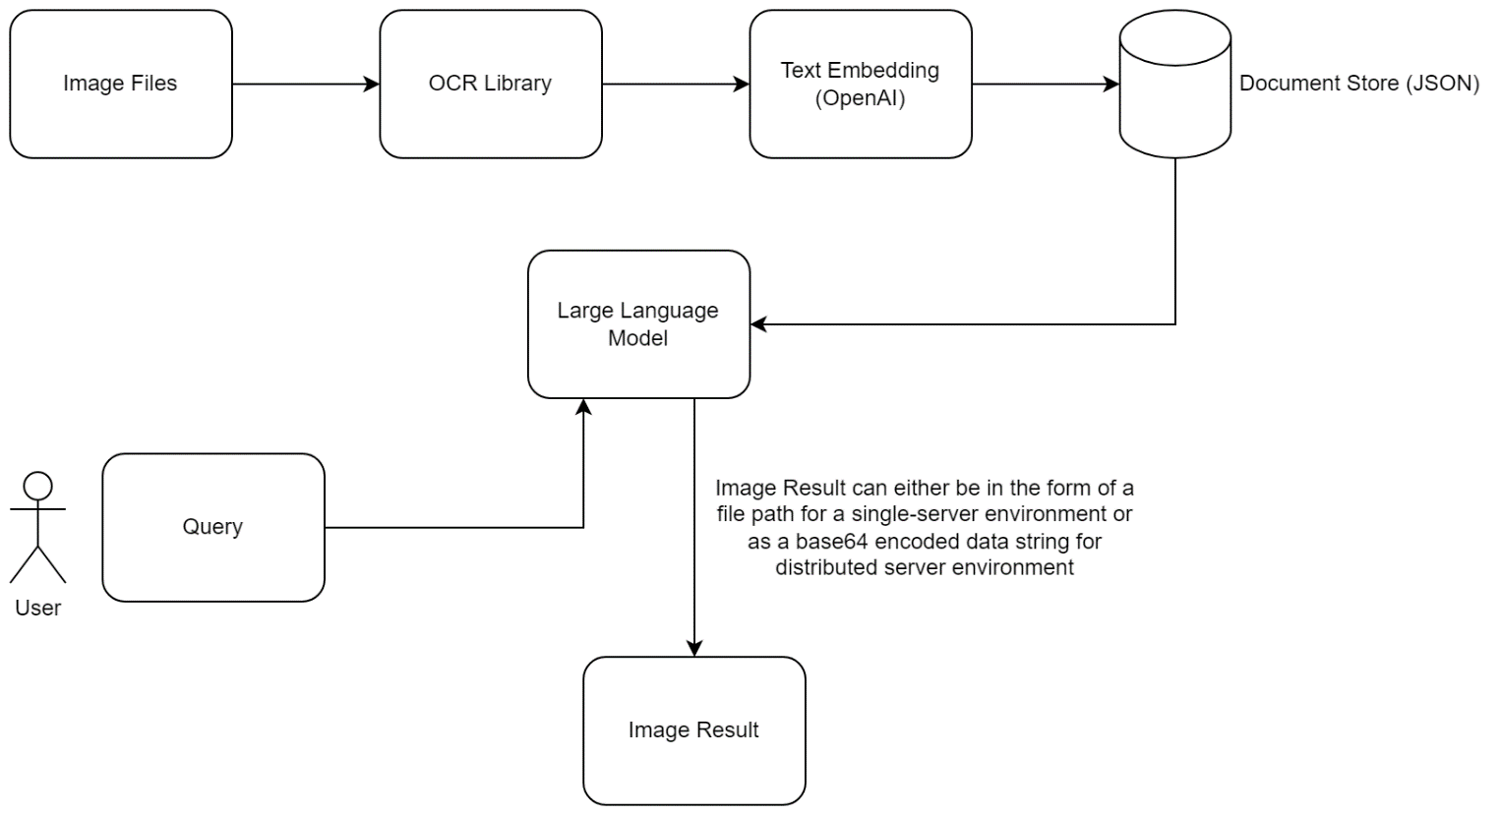

# Technology Stack

The final technological stack after going through the system design concept is illustrated in the following diagram.

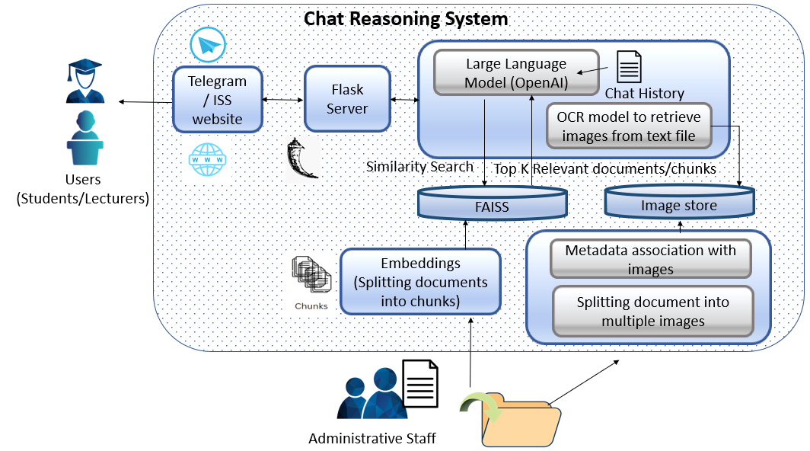

Figure 5: Technology Stack of ChattyISS

# System Implementation and Deployment

# 7.1. Server Installation and Setup

## 7.1.1 Installation setup

ChattyISS is already hosted in Azure. However, it is possible to install and run in your local machine.

Use an Ubuntu machine or WSL. Ensure that Python3 has been installed in the machine.

Download the latest code from the following Github location:

[sink257/IRS-PM-2023-03-06-ISY5001-GRP-Two.AI-ChattyISS](https://github.com/sink257/IRS-PM-2023-03-06-ISY5001-GRP-Two.AI-ChattyISS)  (github.com)

Navigate to /SystemCode/backend/endpoint folder



Download all the necessary requirements by running the following command.

|  |
| --- |
| chmod +x install.sh  ./install.sh |

Setup a cron task to perform daily OCR.

|  |
| --- |
| chmod +x cronTask.sh  crontab –e |

This will open a table in the default text editor. Add a new line at the bottom of the file and specify the schedule and command to execute.

|  |
| --- |
| 0 0 * * * cronTask.sh |

### 7.1.1.1 Backend Service

Retrieve your OpenAI API key from

<https://platform.openai.com/account/api-keys>

Navigate to /SystemCode/backend/endpoint/NUS_ISS_chatbot folder

Edit chatbot.py, chatbot_gpt4.py and understandingimages_llama.py with your API key.

|  |
| --- |
| import os  os.environ[“OPENAI_API_KEY”] = {Your API Key} |

Navigate to /SystemCode/backend/endpoint/ folder.

Run the backend server using the following command.

|  |
| --- |
| python3 main2.py |

The following output should be shown:



Verify that the backend server is running by navigating to the link in your preferred web browser as shown above.

The following webpage should be shown:

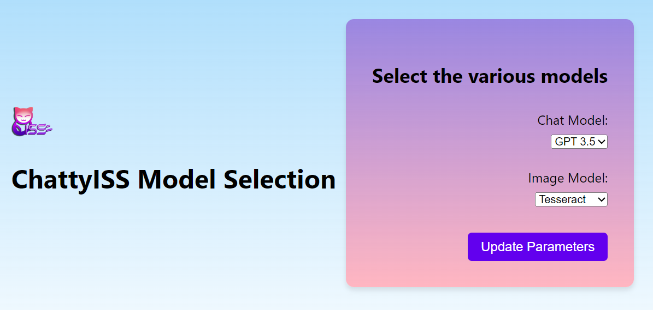Leave the default settings untouched.

## 7.1.2 Frontend Service

### 7.1.2.1 Telegram Service

Navigate to /SystemCode/frontend/telegram



Download the necessary python libraries by typing the following command:

|  |
| --- |
| pip install –r requirements.txt |

To launch the telegram backend service, type the following command:

|  |
| --- |
| python3 telegram.py |

This shall launch the telegram frontend service.

### 7.1.2.2 NUS-ISS Website

Navigate to /SystemCode/frontend/website folder



To launch this pseudo-NUS ISS server, simply run the shell script:

|  |
| --- |
| ./runserver.sh |

To modify existing NUS ISS website to incorporate the iFrame, copy the NUS-ISS_files and chatextension folders into the webserver directory containing the main web page of NUS-ISS.

In the main HTML file of NUS-ISS, insert the following html syntax into the main html file.

|  |
| --- |
| <link rel="stylesheet" href="chatextension/chatbot_styles.css"> <script src="chatextension/chatbot_scripts.js"></script> <div id="chat-component-container"></div> <script>  // Load chat component  async function loadChatComponent() {  const response = await fetch('chatextension/chat_component.html');  const content = await response.text();  document.getElementById('chat-component-container').innerHTML = content;  }  loadChatComponent(); </script> |

# Testing and Test Results

The objective of the following test cases is to verify that the chatbot functions are working as intended and that it can provide an appropriate response given these user scenarios.

## 8.1 **Test** Cases

- Web Interface Test  
- Telegram Interface Test  
- Basic Query Test  
- Temporal Query Test  
- Context Aware Test  
- Image-related Query Test

**8.1.1 Web Interface Test**

|  |  |  |  |
| --- | --- | --- | --- |
| **No** | **Test Description / Procedures** | **Expected Results** | **Result (Pass/Fail)** |
| 1. | Use Chrome Browser, login to [http://20.163.11.67:8000](http://20.163.11.67:8080) | A mock-up NUS webpage is shown | Pass |
| 2. | Click on the chat button on the bottom right corner of the page | A pop-up chat window is shown | Pass |
| 3. | Type “Who is Dr. Tian Jing?” in the chat box and click Send | After a short while, a response describing Dr. Tian Jing is shown | Pass |

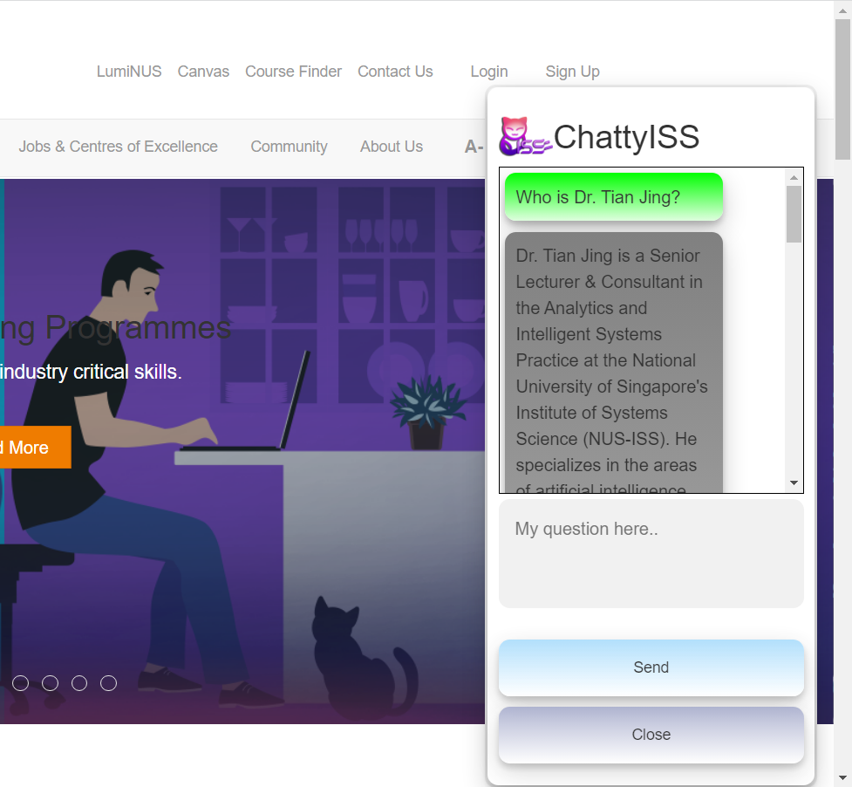

**8.1.2 Telegram Interface Test**

|  |  |  |  |
| --- | --- | --- | --- |
| **No** | **Test Description / Procedures** | **Expected Results** | **Result (Pass/Fail)** |
| 1. | Open Telegram App and open a chat with @ChattyISS | The telegram chat window is shown | Pass |
| 2. | Press start button | A welcome message is shown | Pass |

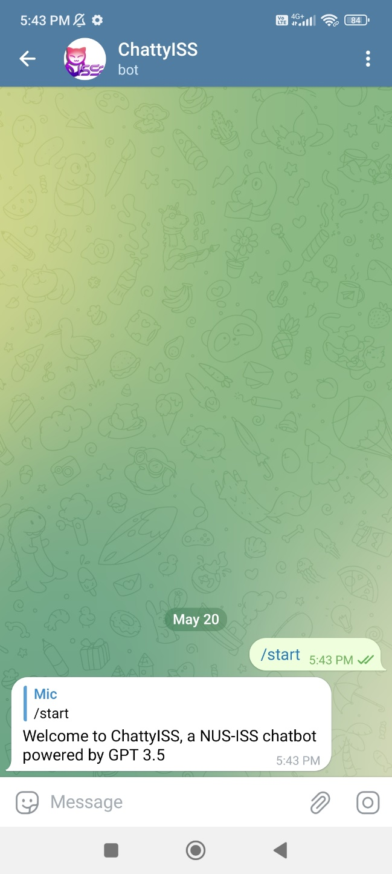

**8.1.3 Basic Query Test**  
This test case steps continues from the end of 8.1.2

|  |  |  |  |
| --- | --- | --- | --- |
| **No** | **Test Description / Procedures** | **Expected Results** | **Result (Pass/Fail)** |
| 1. | Type “Hello” and press the telegram send button | After a short while, the chatbot replies with a greeting message | Pass |
| 2. | Type “What programmes does NUS-ISS offer?” and press the telegram send button | After a short while, the chatbot replies with a message regarding NUS-ISS graduate programmes | Pass |

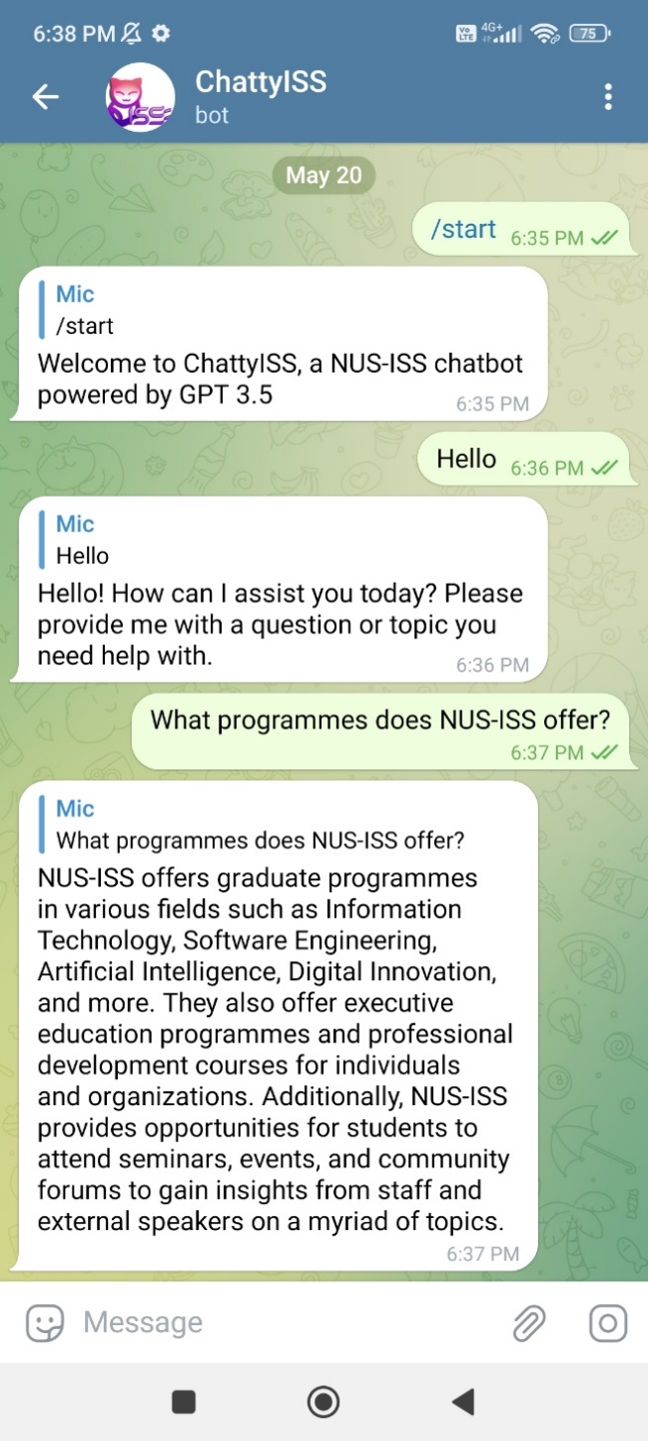

**8.1.4 Temporal Query Test**  
This test case steps continues from the end of 8.1.3

|  |  |  |  |
| --- | --- | --- | --- |
| **No** | **Test Description / Procedures** | **Expected Results** | **Result (Pass/Fail)** |
| 1. | Type “Where is the classroom for Cognitive Systems today?” and press the telegram send button | After a short while, the chatbot replies with a message stating the location of the class for the stated date. | Pass |

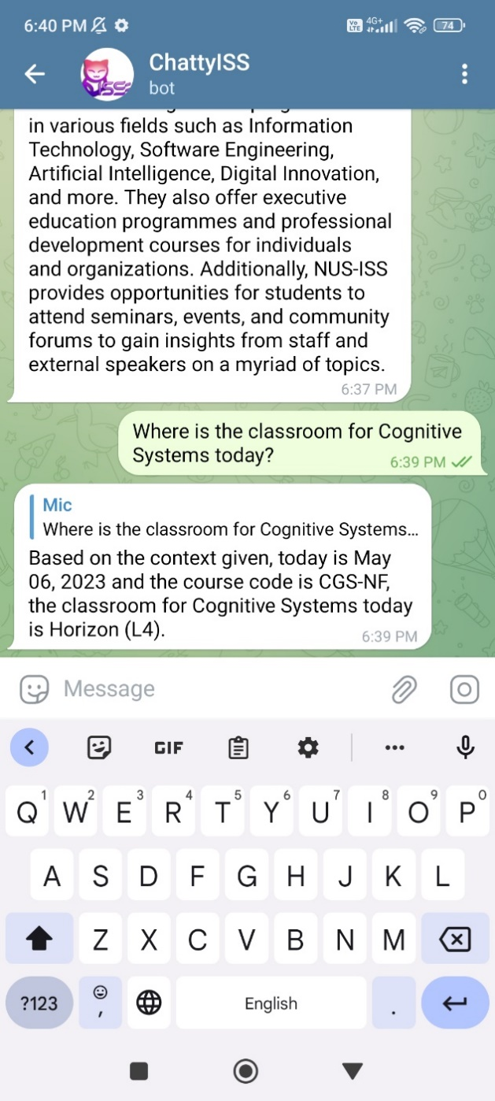

**8.1.5 Context Aware Test**  
This test case steps continues from the end of 8.1.4

|  |  |  |  |
| --- | --- | --- | --- |
| **No** | **Test Description / Procedures** | **Expected Results** | **Result (Pass/Fail)** |
| 1. | Within 5 mins from the previous question, type “How about for 2 weeks ago?” and press the telegram send button | After a short while, the chatbot replies with a message stating the location of the previously mentioned class for the stated date. | Pass |

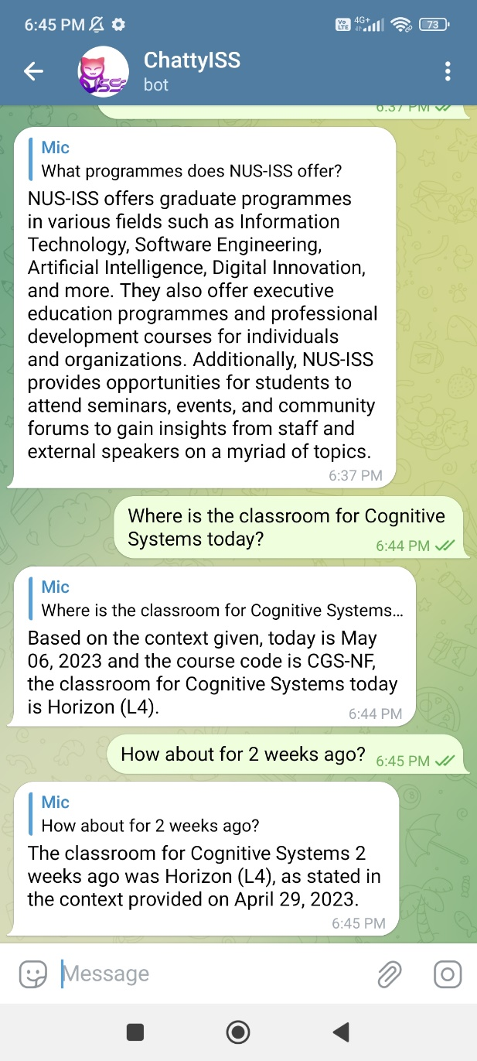

**8.1.6 Image-related Query Test**  
This test case steps continues from the end of 8.1.5

|  |  |  |  |
| --- | --- | --- | --- |
| **No** | **Test Description / Procedures** | **Expected Results** | **Result (Pass/Fail)** |
| 1. | Type “Who is Sam?” and press the telegram send button | After a short while, the chatbot replies with a message with information on Sam, together with an image attachment about Sam. | Pass |
| 2. | Type “Who is Zhen Zhen?” and press the telegram send button | After a short while, the chatbot replies with a message with information on Dr. Zhen Zhen, together with an image attachment about Dr. Zhen Zhen. | Pass |

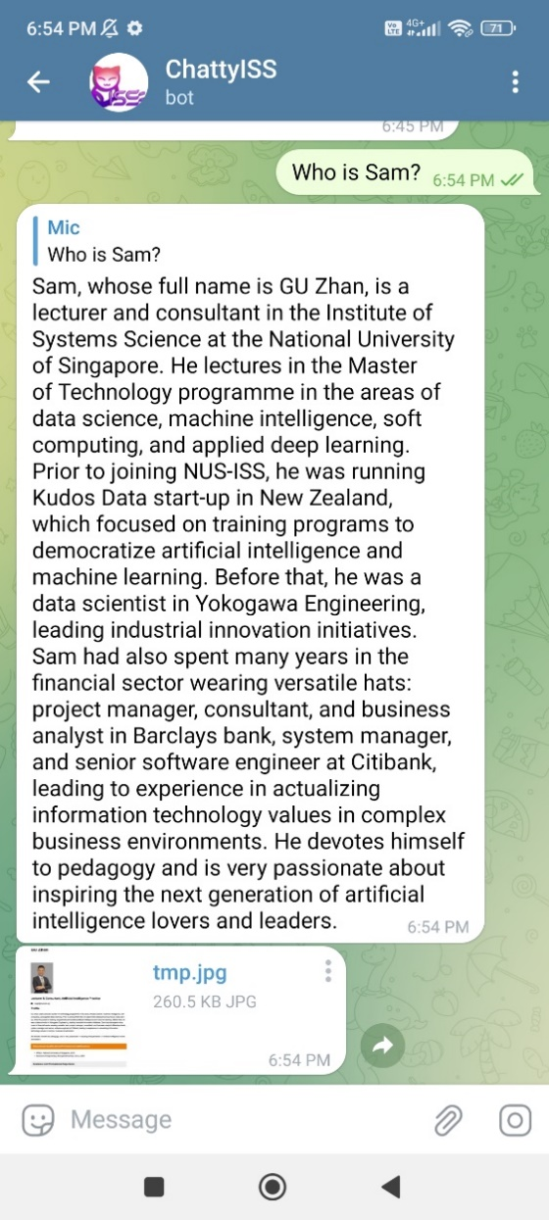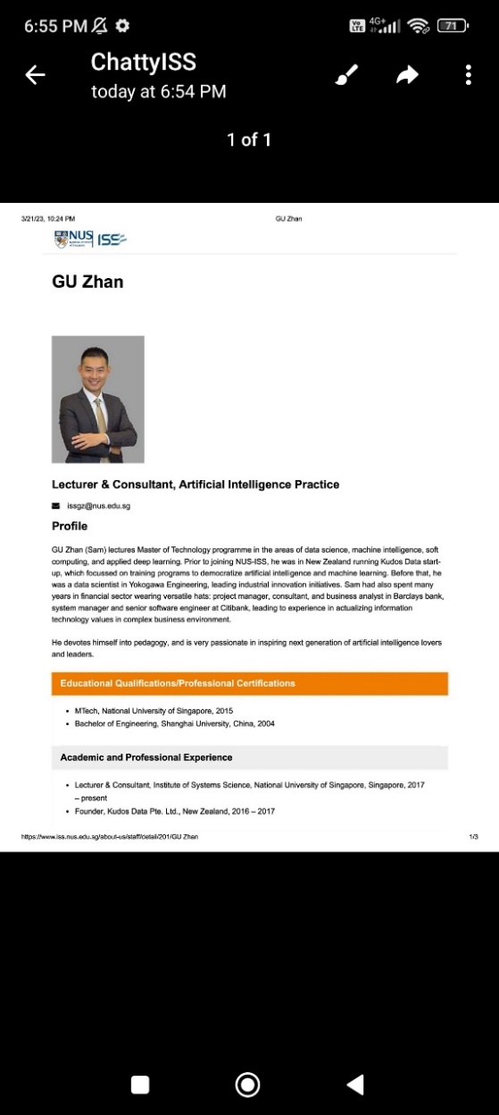

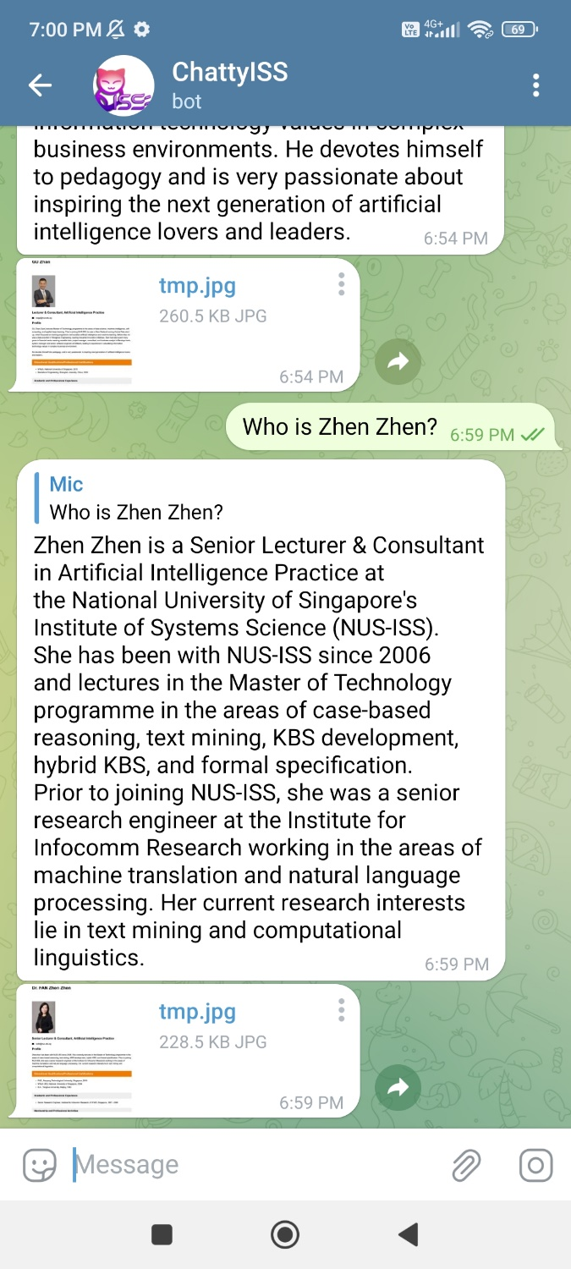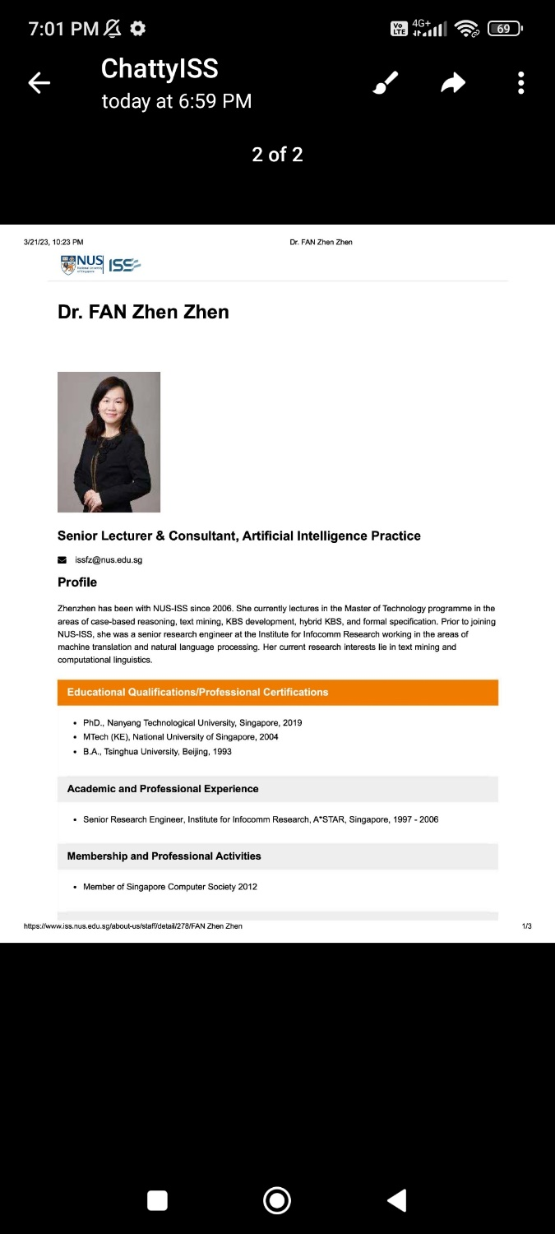

# Limitations and future enhancements

## 9.1 Limitations

As our chatbot is linking to OpenAI’s service through an API key, the time taken to retrieve a response is dependent on the API service and the demand of requests at the point in time of the query. This means that if there is a lot of traffic currently on OpenAI end, the response will take significantly longer for our chatbot.

## 9.2 Future Enhancements

As this is an MVP, there are other future enhancements that we can bring to the systems or process flow of our design system.

1. Currently, the NUS-ISS documents are in local directory and ingested manually. To better improve the process, we can host the documents on sharepoint, along with a power automate flow to transfer these files into an Azure Blob Storage. The power automate flow will also drop newly added files from the sharepoint into the blob storage. We can also enhance our ingestion script to add in these new files into our vector store every night, instead of doing a full overwrite every time there is new documents being uploaded.

# Conclusion

Even though there has already been several chatbot application projects, our goal for this project is to try something novel by leveraging the strengths of large language models (LLMs) to create a smart chatbot which can enhance the overall user experience.

A smart chatbot offers distinct advantages over simple FAQ bots. While FAQ bots are limited to providing predefined responses based on a set of predetermined questions, a smart chatbot can leverage artificial intelligence and natural language processing capabilities to offer a more personalized and dynamic user experience. By offering more comprehensive and nuanced answers, a smart chatbot can increase user satisfaction and reduce frustration.

Another key feature of our smart chatbot is the ability for administrative users to upload new and updated documents which can then be automatically processed and used by the chatbot towards answering users’ queries. This solves one of the main problems with simpler chatbots, in that the information they can provide tends to get outdated over time.

Overall, the value provided by smart chatbots lies in their ability to offer accurate, personalized, and adaptive interactions. By leveraging advanced AI technologies, smart chatbots can understand and respond to user queries effectively, learn and improve over time, offer personalized recommendations, and provide support across multiple channels. These capabilities make them invaluable tools for businesses and organizations, enhancing customer service, streamlining operations, and delivering a superior user experience.

# Appendix

# Appendix A1 – Project proposal

|  |
| --- |
| **Date of proposal:**  5 March 2023 |
| **Project Title:**  ISS Project – Improved NUS-ISS Chatbot |
| **Sponsor/Client:** *(Name, Address, Telephone No. and Contact Name)*  Institute of Systems Science (ISS) at 25 Heng Mui Keng Terrace, Singapore  NATIONAL UNIVERSITY OF SINGAPORE (NUS)  Contact: Mr. GU ZHAN / Lecturer & Consultant  Telephone No.: 65-6516 8021  Email: [zhan.gu@nus.edu.sg](mailto:zhan.gu@nus.edu.sg) |
| **Background/Aims/Objectives:**  The current NUS-ISS website seems to be targeted at prospective students rather than existing students. It is difficult to search for related information and data pertaining to non-curriculum (such as nearest canteen, nearest facilities) or student guides (student handbooks).  According to [Gartner](https://www.gartner.com/en/newsroom/press-releases/2022-07-27-gartner-predicts-chatbots-will-become-a-primary-customer-service-channel-within-five-years#:~:text=STAMFORD%2C%20Conn.%20July%2027%2C%202022%20Gartner%20Predicts%20Chatbots,a%20quarter%20of%20organizations%2C%20according%20to%20Gartner%2C%20Inc.), chatbots can improve customer experience and drive positive customer emotion at a lower cost than live interactions.  A diagram of a chatbot  Description automatically generated with low confidence  Statistics captured from http://outgrow.co  It has been identified that there are already existing NUS-ISS chatbots developed. These NUS-ISS chatbots cannot provide accurate responses to queries and are confined to fixed responses. They only accept limited follow-up questions. These chatbots are also outdated and do not provide easy means for extension. Frequent changes to the NUS-ISS curriculum or information could not be easily updated into the chat system.  The proposed intelligent chatbot is going to address these gaps of the current NUS-ISS chatbots. The delivery of the MVP (Minimum Viable Prototype) is going to demonstrate the chatbot’s capability of delivering accurate and up-to-date information. In addition, a report will be produced comparing our improved NUS-ISS Chatbot with the existing chatbots in terms of its accuracy, response time and extensibility.  In this chatbot, we also aim to provide means to parse and understand documents/FAQs found in Microsoft SharePoint /directories. This provides an easy means for lecturers to update the knowledge base of the chatbot without the need for manual intervention. Additionally, a screenshot of the document with the section that is relevant to the answer will be attached, to provide proof of the accuracy of the answer. |
| **Requirements Overview:**   * Programming ability * Data analytics ability * System integration ability |
| **Resource Requirements (please list Hardware, Software and any other resources)**  Software proposed for consideration:   * Chat-bots: Azure Language Studio * Chatbot Client: Telegram, Chat within website * Cloud computing/server: Microsoft Azure * Document Understanding: TBD (UiPath, Microsoft…) |
| **Number of Learner Interns required: (Please specify their tasks if possible)**  A team of four project members   |  |  |  |  | | --- | --- | --- | --- | | Name | Matriculation | Roles & Responsibilities | Remarks | | LEE KAH WAI | A0019705H | Project Lead | Development tasks will be further split among the 4 team members | | SANKALP | A0226756W | Configuration Manager | | SEOW TECK HAN, MICHAEL | A0270178B | Business Manager | | WEE DE LI, DARREN | A0269370X | Technical Manager | |
| **Methods and Standards:**  The NUS-ISS Chatbot is both a learning and reasoning system.  It is a reasoning task because existing content (knowledge) could be found in the existing website. However, we cannot assume that it is only a reasoning task because NUS ISS is constantly updating its curriculum. It needs to also be a learning task (something that is missing from previous chatbots)  A picture containing text, diagram, line, screenshot  Description automatically generated  Note: Regarding KPI, the actual percentage of accuracy will be compared against improved chatbot and a sample of existing chatbots.  Documents in  SharePoint/  directories  Document Understanding  The Internet  Mobile Phone (Telegram)  ISS web page (Integrated chatbot)  Azure Learning Studio  JSON web API queries & responses  Web endpoint to processed text queries.  Student questions in form of JSON web API queries.  Inference system  Knowledge base  Formulation of JSON response  JSON web API responses.  Inference system within Azure Learning Studio   |  |  |  | | --- | --- | --- | | **Procedures** | **Objective** | **Key Activities** | | **Requirement Gathering and Analysis** | The team should capture the requirements specifications in Scrum board provided in Notion. | 1.        Gather & Analyze Requirements  2.        Define internal and External interfaces  3.        Prioritize & Consolidate Requirements  4.        Establish Functional Baseline | | **Sprints** | To incrementally develop the Chatterbot in several iterations. However instead of providing the MVP in each sprint, the MVP will only be delivered after an obvious prototype is developed. These modules could be done in parallel or sequentially.   * Simulating the training data (Possible Q&A) * Development of the backend web API endpoint * Development of the front-end | 1. Setup Development Environment in Server/Client 2. Installation of appropriate tools 3. Coding and implementation | | **Delivery & Acceptance of MVP** | Metrics to validate that the current chatbot has a better accuracy than listed chatbots found in [https://github.com/IRS-CGS](https://github.com/IRS-CGS/IRS-CS-2019-04-27-IS1PT-GRP-ISSChatBot)  To deploy the MVP system into production environment. | 1. Summary report of evaluation   Free-Play / Evaluation results   1. Software must be packed by following ISS’s standard. 2. Deployment guideline must be provided in ISS production (ISS standalone server) format. 3. Production (ISS standalone server) support and troubleshooting process must be defined. | |

**Team Formation & Registration**

|  |
| --- |
| Team Name: Two.AI |
| Project Title (repeated):  Improved NUS-ISS Chatbot |
| System Name (if decided):  ChattyISS |
|  |
| Team Member 1 Name:  Lee Kah Wai |
| Team Member 1 Matriculation Number:  A0019705H |
| Team Member 1 Contact (Mobile/Email):  94510840 / E1111840@u.nus.edu |
|  |
| Team Member 2 Name:  Wee De Li, Darren |
| Team Member 2 Matriculation Number:  A0269370X |
| Team Member 2 Contact (Mobile/Email):  83827015 / e1112241@u.nus.edu |
|  |
| Team Member 3 Name:  Seow Teck Han, Michael |
| Team Member 3 Matriculation Number:  A0270178B |
| Team Member 3 Contact (Mobile/Email):  91370145 / e1117140@u.nus.edu |
|  |
| Team Member 4 Name:  Sankalp |
| Team Member 4 Matriculation Number:  A0226756W |
| Team Member 4 Contact (Mobile/Email):  96622754 / sankalp@u.nus.edu |

# Appendix A2 – Mapped System Functionalities against knowledge, techniques and skills of modular courses: MR, RS, CGS

# Appendix A3 – Installation and User Guide

The core installation of the chat bot system could be found in Section 5 of this document.

This section describes the setup on the client side.

## 11.3.1. Telegram application

To install the telegram bot, the user will need to have the telegram application installed on their mobile phone.

Search for the telegram application by typing “@chattyiss” as shown in the textfield:

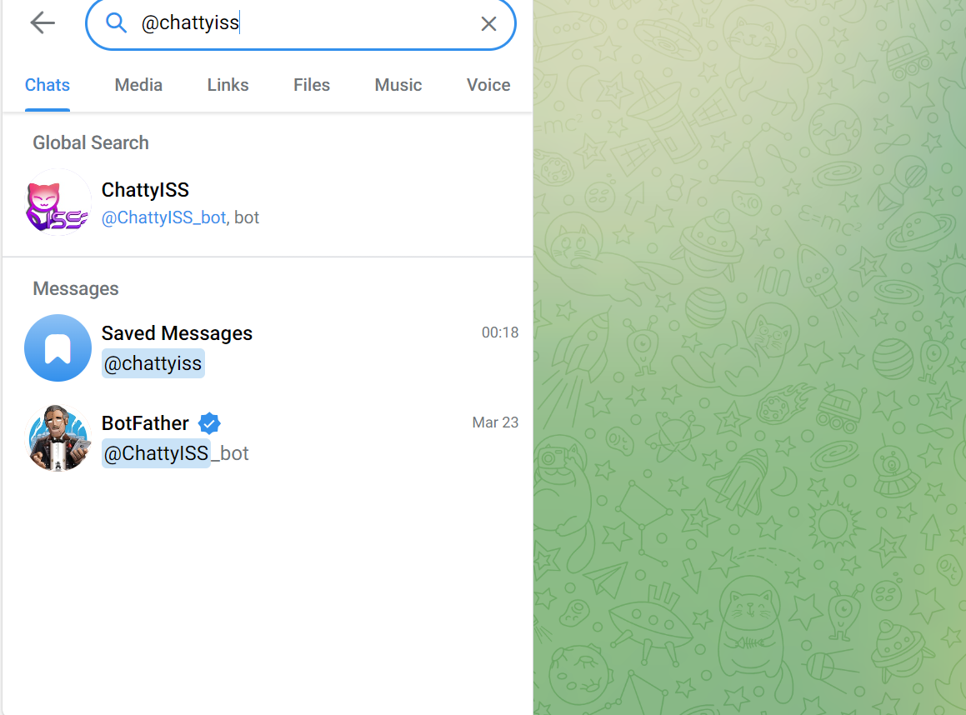

*Note: If you want to host your own Telegram Bot, retrieve the API key from BotFather. Modify telegram.py accordingly with your API key.*

Click on the “Start” button or type “/start” in the textbox.

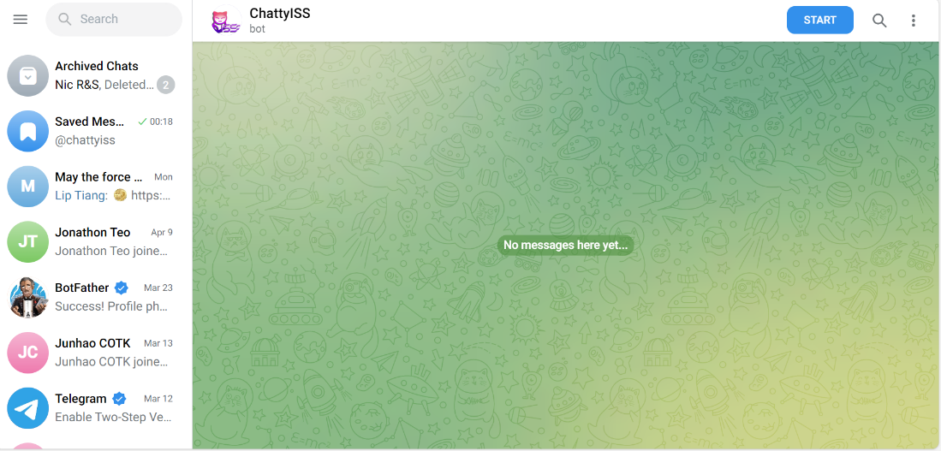

The user can start the conversation immediately.

## 11.3.2. ISS Website

We have an existing emulated version of ISS website.

Navigate to [http://20.163.11.67:8000](http://20.163.11.67:8080)

The following website should be shown:

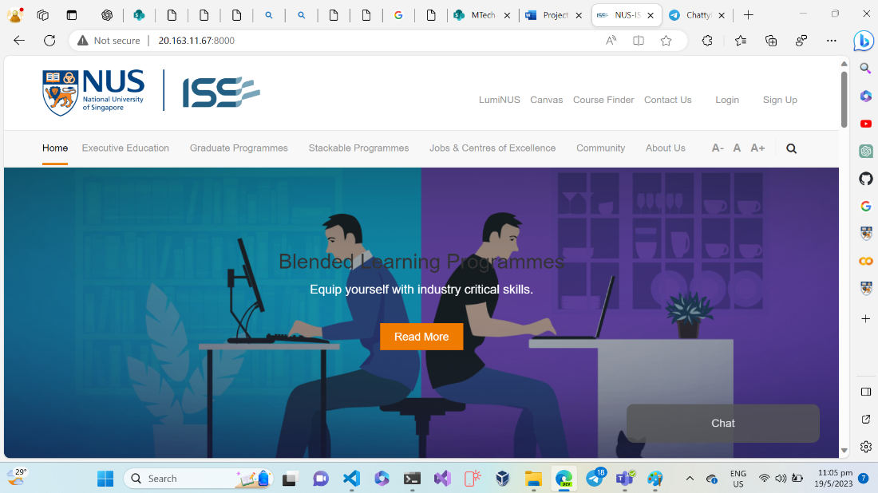

Click on the Chat button found in the bottom right-hand corner.

A text field shall appear as shown below:

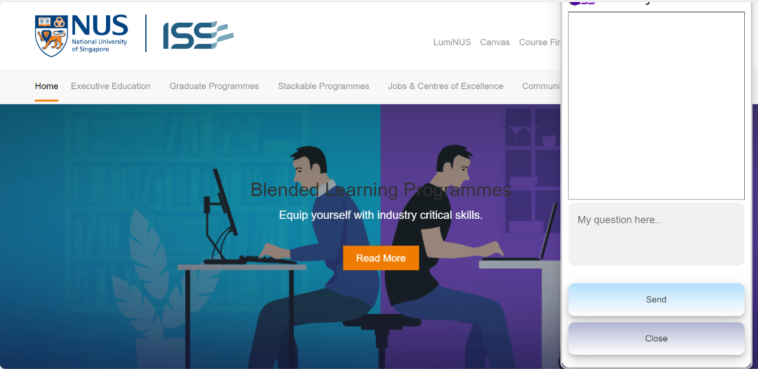

The user can send the queries here.

Note: If you are hosting on your own machine, simply navigate to SystemCode/frontend/website.

Execute the runserver.sh script.

*Note: The chatbot system is currently hosted as a cloud in Azure.*

*Depending on the available credits, the Chatbot might not be available for testing.*

# Appendix A4 – Individual Project Report

|  |
| --- |
| Team Member 1 Name:  Lee Kah Wai |
| 1. Personal Contributions  * Project coordinator for project. * Distribution of work to team * Work on assessment, development of frontend system * Work on assessment, development of endpoint system * System integration for the System * Host application on Azure * Creation of Business Video  1. Most valuable knowledge/skills acquired.  * To always consider a metrics to evaluate a solution. * Come out with alternatives and evaluate the choices.  1. How to apply knowledge/skills acquired in your workplaces  * The approach to carefully evaluate choices is applicable beyond evaluating machine reasoning solutions. It’s applicable for most context, even on programmatic decisions. |
|  |
| Team Member 2 Name:  Wee De Li, Darren |
| 1. **Personal Contributions**   My responsibility in our group project was primarily focused on the technical aspects and modelling. This involved researching and selecting various packages and methodologies to develop a chatbot capable of answering queries related to our school, NUS-ISS. After evaluating different approaches, I opted for LangChain as it offers a unified framework for document ingestion, word embeddings, and leveraging a large language model to respond to questions based on similar documents. Throughout the development phase, I conducted thorough testing to ensure the accuracy of our chatbot and made necessary improvements to enhance its performance.   1. **Most valuable knowledge/skills acquired**   Exploring current and latest methods out of the curriculum, in particular related to chat bots. As we learned traditional nlp methods in the course, such as intent classification and entity recognition, it is also important to explore what are current solutions out there, especially with the rise of Chat-GPT.   1. **How to apply knowledge/skills acquired in your workplaces**   The project has allowed me to explore the current solutions that is able to take advantage of the latest current large language model, Chat-GPT. In particular, utilising Chat-GPT to answer queries on your own documents is very powerful, especially to an organisation. I have started doing pilot testing from what I have done in the project, to apply to my company, creating a similar chatbot on my company’s Human Resource policies. This has help to pitch the idea to lighten the workload of our Human Resources Business partners by helping them address employees ’queries through the chat bot. |
|  |
| Team Member 3 Name:  Seow Teck Han, Michael |
| 1. **Personal Contributions**  * As the role of Business Manager for this project, conducted market research on the viability of chatbot systems. * Did research and testing on image recognition solutions and came up with the design for the image processing subsystem. * In charge of planning of test cases and conducting testing of chatbot system functionalities. * Summarize the objectives and goals of the project into a conclusion.  1. **Most valuable knowledge/skills acquired**   Working on this project has allowed me to gain a greater understand of how large language models work and how to use APIs to develop applications that make use of these models to generate useful responses based on natural language input.  As the project encompasses several different types of systems, I also gained greater experience on how to use a variety of development tools like Git and WinSCP to upload and transfer files between the systems and the repository.  A large part of the system also focuses on Natural Language Processing (NLP), and specific knowledge with regards to NLP is getting more and more important as the usage of AI becomes more mainstream.   1. **How to apply knowledge/skills acquired in your workplaces**   Generally, in most workplaces, the usage of ChatGPT is gaining traction as a means to enhance the efficiency and quality of work processes. As this project interfaces with ChatGPT models, I have gained a better understanding on how ChatGPT works and how the prompts work in affecting its behaviour.  The knowledge on development tools will also come in handy as part of my software team’s development process and provides more options in handling software integration and deployments.  Working on the project has broadened my view on how AI chatbots can be used, and can prove useful in allowing me to come up with new proposals and ideas for future upcoming projects. |
|  |
| Team Member 4 Name:  Sankalp |
| 1. Personal Contributions  * Was the release manager for the project * Worked on creating and maintaining the GitHub repository * Researched on large language models to use for question answering. * Researched on technologies to use for the frontend/backend. * Created the template for the final report. * Created the technical video for the project.  1. Most valuable knowledge/skills acquired.  * I gained experience on how embeddings work in the context of Large Language Models. * I also found out more about the text recognition using OCR.  1. How to apply knowledge/skills acquired in your workplaces  * This project has given me a good idea on how important the availability of information is. As we were working on the project, it becomes clear that having to hunt down information as someone who is a student or even a staff can be really tedious. Projects like ours can save people a lot of time and headache, and it can be carried over to lots of other workplaces and departments where people need to quickly access accurate information |

# Appendix B – Gartner Report

According to [Gartner](https://www.gartner.com/en/newsroom/press-releases/2022-07-27-gartner-predicts-chatbots-will-become-a-primary-customer-service-channel-within-five-years#:~:text=STAMFORD%2C%20Conn.%20July%2027%2C%202022%20Gartner%20Predicts%20Chatbots,a%20quarter%20of%20organizations%2C%20according%20to%20Gartner%2C%20Inc.), chatbots can improve customer experience and drive positive customer emotion at a lower cost than live interactions.

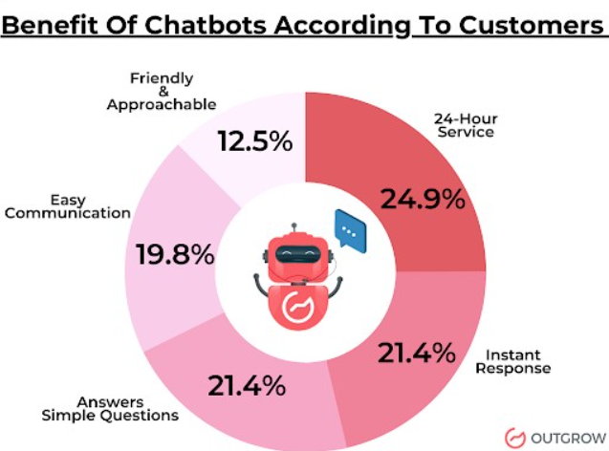

Statistics captured from http://outgrow.co

# Appendix C – References

1. [The](https://www.testingtime.com/en/blog/important-ux-kpis/) 7 most important UX KPIs and how to measure them - TestingTime

1. [20](https://www.zippia.com/advice/smartphone-usage-statistics/" \l ":~:text=Here%20are%20the%20facts%3A%201%20The%20average%20American,have%20broadband%20but%20do%20have%20a%20smartphone.%20) Vital Smartphone Usage Statistics [2023]: Facts, Data, and Trends On Mobile Use In The U.S. - Zippia
2. [WhatsApp Chatbot vs Web Chatbot: Advantages & Disadvantages for a Business (wati.io)](https://www.wati.io/blog/whatsapp-chatbot-vs-web-chatbot/)